Audio Engineering Society
AES
Convention Paper
Presented at the 126th Convention
2009 May 7–10 Munich, Germany
The papers at this Convention have been selected on the basis of a submitted abstract and extended precis that have been peer reviewed by at least two qualified anonymous reviewers. This convention paper has been reproduced from the author's advance manuscript, without editing, corrections, or consideration by the Review Board. The AES takes no responsibility for the contents. Additional papers may be obtained by sending request and remittance to Audio Engineering Society, 60 East 42nd Street, New York, New York 10165-2520, USA; also see www.aes.org. All rights reserved. Reproduction of this paper, or any portion thereof, is not permitted without direct permission from the Journal of the Audio Engineering Society.

The importance of the direct to reverberant ratio in the perception of distance, localization, clarity, and envelopment

David Griesinger
¹ 23 Bellevue Avenue, Cambridge, MA 02140, USA
dgriesinger@verizon.net
www.davidgriesinger.com

ABSTRACT

The Direct to Reverberant ratio (D/R) - the ratio of the energy in the first wave front to the reflected sound energy - is absent from most discussions of room acoustics. Yet only the direct sound (DS) provides information about the localization and distance of a sound source. This paper discusses how the perception of DS in a reverberant field depends on the D/R and the time delay between the DS and the reverberant energy. Threshold data for DS perception will be presented, and the implications for listening rooms, hall design, and electronic enhancement will be discussed. We find that both clarity and envelopment depend on DS detection. In listening rooms the direct sound must be at least equal to the total reflected energy for accurate imaging. As the room becomes larger (and the time delay increases) the threshold goes down. Some conclusions: typical listening rooms benefit from directional loudspeakers, small concert halls should not have a shoe-box shape, early reflections need not be lateral, and electroacoustic enhancement of late reverberation may be vital in small halls.

Introduction
The work of pioneers such as Michael Barron greatly influenced by research into spatial acoustics. Barron studied the perceptual effects of adding (lateral) reflections to the direct sound from a loudspeaker. Fascinated by this work, I researched how our physiology decodes the properties of a spatial sound field, how we determine the loudness of the reverberant component of a sound field, and the effects of different combinations of early and late reflections on recorded sound. [1] [2] [3]

For example, when we record a sound source with a closely spaced microphone it is perceived on playback as uncomfortably close to the listener. We found that (lateral) reflections in the time range of 10 to 50ms can contribute a sense of distance to the sound image, pushing it away from the listener and behind the loudspeakers. Such reflections additionally generate a room impression front of the listener – as if we were perceiving a room through an open window. A major contribution was the discovery that it is the total energy of the reflections that produces the effect. Each reflection might be individually inaudible, but together be quite significant.

Reflections later than 50ms create a “spaciousness” impression that surrounds the listener. The effectiveness of these reflections in producing the surround impression increases as the delay increases, up to about 160ms. If there are a collection of reflections of approximately equal level between 50 and 160ms a strong enveloping reverberance is perceived, with no sense of echo.

Michael Barron found much the same result using single reflections, as shown in the well known drawing in Figure 1. Note the vertical axis is the ratio of reflection to direct (R/D). This paper will concern itself with the inverse: the direct to reverberant ratio (D/R). The vertical axis of Barron’s diagram covers the D/R range of +20dB to 0dB.

Barron’s and our research has been both interesting and useful in understanding sound recording and reproduction. Recording engineers often start with a collection of tracks that are essentially free of reverberation. They mix these tracks together and then add (naturally or artificially generated) reflections and reverberation to create a natural sounding final product.

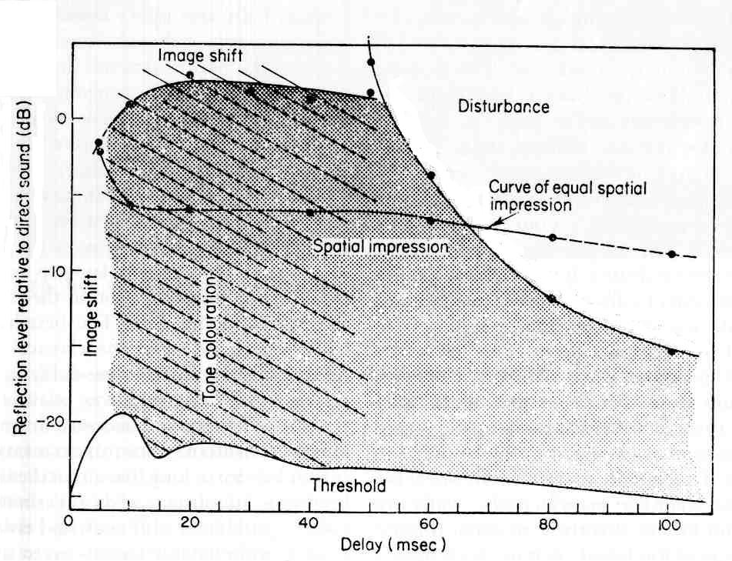
Figure 1 The subjective effects with music of a single side reflection as a function of reflection level and delay relative to the direct sound (azimuth angle 40 degrees). From Barron. [4]
Barron’s and our research has been both interesting and useful in understanding sound recording and reproduction. Recording engineers often start with a collection of tracks that are essentially free of reverberation. They mix these tracks together and then add (naturally or artificially generated) reflections and reverberation to them to create a natural sounding product.

Note that the vertical scale in Barron’s diagram goes from a ratio of reflected energy to direct (R/D) of -25dB to +5dB. The D/R ratio is thus -5dB to plus 25dB. This range is appropriate for recorded music. We have found that for nearly all recorded music – classical or popular – the D/R is never less than +4dB. Thus the direct energy – the first wave front – always has at least twice the sound power as the sum of all reflected sound. Given a choice of how to set both the early reflection level and the reverberation level, both sound engineers – and even the acousticians I managed to test (Beranek for example) choose a direct to reflected energy ratio (D/R) between plus 4dB and plus 6dB. The “curve of equal spatial impression” in Barron’s figure is drawn at this level.

But Barron was not interested in recorded sound. He was trying to understand concert halls. Very few seats in a hall have a D/R in this range. In a typical shoebox hall the critical distance (the distance where the direct sound and the reflected sound are equal) is 7 meters or less. All seats beyond this distance from a source will have a D/R less than one. In fact, in many halls at least half the seats have a D/R of minus 8dB or less.

This paper presents results of experiments that probe the case where the direct sound is typical of real halls. A primary tool uses simple image source models of halls. The models compute a binaural signal corresponding to the sound of a single instrument at a particular seat. The HRTF functions used are my own, measured at the eardrum. They are reproduced through headphones also calibrated at the eardrum, which eliminates the most common errors in binaural modeling. [5] The direct component of the impulse response is extracted, and both it and the later reverberation are convolved with music. The d/r of the composite signal can be varied experimentally, and a subject can report on how the spaciousness and the localizability of the source varies.

Many alterations of the reverberant signal are possible. For example, specific reflections can be amplified or attenuated, the directional properties can be eliminated or swapped over particular time ranges, etc. The results have important implications for hall design.

2. EXPERIENCES

This paper is largely about the perception of distance between a performance and an audience member. There is little mention of this perception in music acoustic literature, yet I believe it to be critical both for drama and music. A few personal experiences may be helpful in explaining why it is so important.

Perhaps the first of these was during the installation of the reverberation enhancement system in the Deutchestaatsoper in Berlin. Barenboim had decided to present Wagner’s Ring cycle in the Staatsoper, for the first time since WWII. But he was not happy with the acoustic. The Staatsoper has a natural reverberation time at 1000Hz of 0.9 seconds, and Barenboim wanted something closer to Bayreuth, 1.7seconds. Albrecht Krieger had heard my demonstration at the Schaubuhne Berlin during the AES convention, and suggested to Barenboim that we try the system in the Staatsoper. As a result, Krieger and I installed a shoestring system before the opening of Rhenigold, and I adjusted it till I liked it with my own singing. Krieger was delighted.

But Barenboim was NOT delighted. Horrible, he said. Good on the orchestra, horrible on the singers. He gave me 20 minutes to get it right – and I did. I installed a shelving filter in the microphone inputs, which reduced the reverberant level – not the reverberation time – by 6dB above 500Hz. Barenboim was delighted. Don’t ever change it, he said, and jumped back into the pit.

The sound was indeed wonderful, and remains so to this day. The clarity of the singers is almost unaffected by the reverberation enhancement, while their fundamental tones are rich. Most singers like the effect, although one singer I met claimed that the hall remains as dry as ever. I think he never heard the hall with the system off. This is distinctly not my impression as a singer. I find the enhancement is very audible, and quite helpful. Barenboim was right (as usual). The sound in the audience is glorious. The orchestra is full and rich (the RT below 500Hz is 1.7 seconds), while the singers are clear. It took two years for anyone to realize there were electronics in the hall. All the improvement was attributed to Barenboim’s skill as a music director – perhaps rightly so. There is enormous dramatic intensity. Aurally you are not at some comfortable distance observing the scene – you are in it. The singers seem to be singing or talking directly to you.

The few times the system has needed adjustment (some of the old East German equipment was due for retirement long before) Barenboim has heard the problem immediately from the pit, and has urgently demanded repair.

When we installed system in the Amsterdam Musiktheater, I was able to spend a lot of time with Peter Lockwood, the assistant conductor. He sat with me in a variety of seats while listening to rehearsals. We carried a remote control that allowed us to vary the D/R in half-dB steps. We lowered the D/R gradually, and the sound took on definite richness and depth. (The same reverberant level shelving filter used in Berlin was employed.) But a one point Peter said STOP – that’s too much! I could not hear the difference. Listen, he said. With that one extra half-dB the singer moved back 10 feet! So I listened – and for the first time I appreciated the critical effect reverberation has on the apparent distance of an actor. When the reverberation is below some threshold the singers are perceived as close to the listener – dramatically they occupy the same space. Just a tiny bit more and they leave the space of the listener, and occupy a different space far away. Peter wanted the dramatic connection – and do did Haenchen, the music director.

Haenchen was responsible for my being in the Musiektheater. He had recently come from the position of music director at the Semperoper Dresden, which is a small opera with an RT occupied of at least 1.5 seconds. The Musiektheater is a larger space, with a RT below 1.3s at 1000Hz. Haenchen wanted me to reproduce the sound of the Semperoper in Amsterdam. As it happened, I had visited the Semperoper some years before and had binaural recordings of how it sounds. It is small and quite reverberant. The orchestra is loud, the singers are often overpowered, and often unintelligible. I could plausibly reproduce this acoustic in Amsterdam. Haenchen did not like it at all. I am convinced he was not responding to artifacts in the system, but to the lack of articulation in the singers. “Turn it off!” is all he could say. It is interesting – and the topic of another paper – how human perception can adapt to a particular acoustic and think it wonderful. But when there is the opportunity to change the acoustic rapidly in an A/B comparison, very different preferences are expressed.

But Hanenchen was very happy with Peter’s final adjustment. When the opera directors I have worked with are given the chance to choose immediately between orchestral richness and dramatic intensity they choose dramatic intensity. When this choice does not exist, they LOVE the sound of the orchestra, and the singers be damned.

After a similar experience with Michael Schonewand in the old Royal Theater in Copenhagen, I was asked to install a system in a shoe-box shaped drama theater in a building next to the Royal Theater. The object of the system was to improve the intelligibility of actors during a conventional (speech) drama. We had previously installed 64 Genelec 1029 loudspeakers around the audience, and a pair of Gefeil line-array microphones at the balcony fronts. Alas, the microphones were well beyond the critical distance, and it was not possible to pick up the direct sound from the actors cleanly. I designed a fast acting gate that opened at the beginning of every syllable, and promptly closed just after the syllable ended. This signal was routed with complicated varying delays to the loudspeakers, and the system worked. Both loudness and intelligibility were improved.

A test was arranged. Five of the principle drama directors in Copenhagen were invited to listen in various seats to a live performance of “Uncle Vanya” in Danish, with a full paying audience. The system was turned on and off every 10 minutes, with no audience complaint. At the end of the performance we all got together. The directors were unanimous. “The system works, we don’t like it, turn it off.” Why? The directors were not sure. Finally a reason emerged. The system made the actors louder, and more intelligible, but they sounded further away. The value of D/R had been pushed too low by the system, and the actors disappeared into a different space. “I would rather the audience did not understand the words than to lose the dramatic connection between the actor and the listener” said one of them. “If the audience can’t hear the words they have to concentrate harder – which is just what I want.” But all the directors agreed that they had to train the actors better. The older actors were always intelligible. Some aspect of training had been neglected. When I related this to Schonewand, who had just conducted “Tristan”, he was most amused, and not surprised. “These young actors don’t know how to speak Danish!” he said.

All these experiences have in common the critical relationship between D/R and audience involvement. At the IOA conference in Oslo, Krokstad (the Leo Beranek of Norway) gave a wonderful lecture, where he insisted that what we as acousticians (or sound engineers) were seeking was involvement, not envelopment. His final slide was of the Theatre de Colon in Buenos Aires. ‘Is this the concert hall of the future’ he asked? Our experiences in the new Oslo opera indicate that he is probably right. The Theatre de Colon is a large opera house with a high ceiling. RT is about 1.6 seconds, the audience sits close to the orchestra, the direct sound is audible in every seat, and there is plenty of reverberation.

3. MAIN POINTS

3.1 The ability to hear the Direct Sound – the sound energy that travels to the listener without reflecting – is a vital component of the sound quality in a great hall.

The direct sound – some call it the first wavefront – provides the human brain with the only accurate information about the direction (elevation and azimuth) of the sound source. Where there is sufficient direct sound energy, and sufficient time between the direct sound and the reverberation that the brain can separately perceive the direct sound, both intelligibility and the sense of connection to the sound source are optimized.

As we will see, the ability to separately perceive the direct sound depends on time. Providing the reverberation from a previous sound has sufficiently decayed, the onset of a new sound is always uncorrupted by reflections. But the brain may not be able to separate this onset from the high level of reverberation that follows if the time delay is too short, or if the sound has too gradual a rise-time. If we want to optimize audience involvement as Krokstad insists, we need to make the direct sound separately perceivable.

3.2. Current acoustic measures neglect the audibility of direct sound and audience involvement.

Measures such as C80 lump the direct sound together with a great many early reflections, particularly in small halls. These halls can have what look like good clarity values, but localization and sonic distance can be poor. The current IEC definition of EDT ignores the direct sound, unlike the original definition by Jordan. (And the value obtained depends on the sample rate.) This is why EDT and RT are almost always the same. Calculations of acoustic parameters based on a Schroeder integral obscure the actual D/R, since they assume an infinitely long excitation. Musical notes are seldom infinitely long. Short notes excite the hall less, which increases the D/R and increases the effective critical distance.

We need much better ways of measuring the direct sound and its relationship to later reverberation. Two such measures will be demonstrated here.

3.3. Hall shape does not scale

Our ability to perceive the direct sound depends on its level compared to reflected sound, and on the time-gap between the two. Both the direct to reverberant ratio (D/R) and the time-gap change as the hall size scales – but human hearing (and the properties of music) do not change. A hall shape that provides great sound to a high percentage of 2000 seats may produce a much lower percentage of great seats if it is scaled to a capacity of 1000. Smaller venues produce a shorter delay between the direct sound and the later reverberation. If audience involvement is to be preserved we must: a) specify a shorter reverberation time b) bring the audience closer to the musicians, c) increase the time delay by absorbing or directing first order reflections back to the source, and/or d) increasing the directivity of the musicians by adding absorption (not diffusion) to the stage.

If we demand a longer reverberation time, we must design the hall so the longer reverberation time does not result in a higher reverberation level, as conventional theory says it must. This seemingly impossible trick can in fact be done, both electronically and with (expensive) architecture. (For example, the new Oslo opera house is very well liked as a symphony hall.).

3.4. Small halls have too many early reflections, not too few.

Although acousticians generally believe clarity can be improved in small halls by adding early reflections, the opposite is often the case. Small halls suffer from too high a reverberant level, and a too rapid a build-up of reverberation. Both problems can be alleviated by selectively absorbing or reflecting the earliest arrivals away from the audience – which frequently means absorbing the first lateral reflections. This delays the onset of reverberation long enough to allow the brain to detect the direct sound. Contrary to the current understanding of Barron’s results, the direction of early reflections is NOT audible if the energy of later reflections is dominant.

3.5. The build-up of reflected energy in a hall is at least as important as the way the energy decays – as we will see in the next section.

4. REVERBERATION BUILD-UP

The most important parameter that a sound engineer adjusts when adding reverberation to a music mix is the level – the loudness – of the reverberation. This control is equivalent to adjusting the D/R in a hall. Changing the D/R by one or two dB has a far greater effect on the sound than changing the reverberation time by 30 percent or more.

But sound engineers know that the pre-delay control, the one that changes the delay before the onset of reverberation is also very important to the sound. As the pre-delay increases the effective loudness of the reverberation increases, allowing the engineer to increase the D/R while preserving the spaciousness. The clarity of the recording increases. Too much pre-delay and the reverberation is perceived as an echo – this is clearly undesirable. For this reason some reverberation devices include a method of stretching out a series of early reflections to fill the empty time between the direct sound and the bulk of the reverberation. (At Lexicon we called these controls “shape” and “spread”.) Surprisingly, both D/R and reverberant level have been routinely ignored in hall acoustics.

Two years ago I was asked to write a review article for the IEEE on hall acoustics. The article was supposed to present a mathematical theory of halls that would explain why they sounded the way they do. Conventional theory – Morse and Beranek – could not explain the obvious differences in sound between even the best halls, such as Boston Symphony Hall (BSH), and the Amsterdam Concertgebouw (CB). A simple binaural model of these halls showed clear differences in sound even when the RT was adjusted to be identical. I decided to look carefully at the way sound builds up.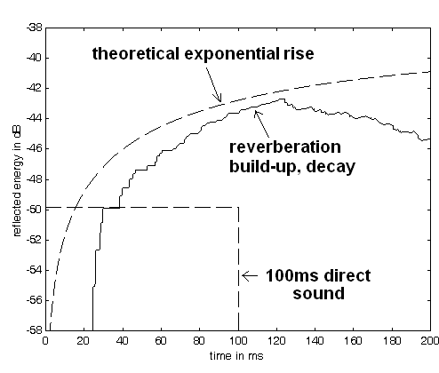Figure 2 Solid line: the build up and decay of reverberation in Boston Symphony hall at a position 70 feet from the stage. The excitation is a note 100ms long. The dashed curve is the theoretical build up of energy from an infinitely long excitation of the same amplitude. Note the ~23ms time delay before the amplitude of the reverberation exceeds the amplitude of the direct sound.

BSH is a wonderful hall. There is clarity and localization over a wide range of seats. From about row 10 to row 30 the sound is nearly identical and very good. It degrades slowly further back. The sound is identical because once the threshold for the detection of direct sound is exceeded, very little changes as the D/R increases further. The loudness is almost entirely provided by the reflected energy.
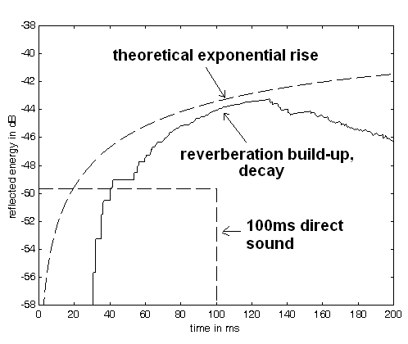
Figure 3 Solid line: build up and decay of reverberation in the Concertgebouw at 60 feet from the stage. The excitation is a note 100ms long. The dashed curve is the theoretical build up of energy from an infinitely long excitation of the same amplitude. Note the ~35ms time delay before the amplitude of the reverberation exceeds the amplitude of the direct sound.

Figures two and three show a very clear difference in pre-delay between the two halls. Boston has the shorter pre-delay, and is perceived as less reverberant, and less spacious, at least to the author. The Concertgebouw is more reverberant and spacious, with a marvelous clarity about the direct sound. But with some instruments, such as solo piano, there can occasionally be disturbing echoes.

Note that the direct sound plays a vital role in these two halls. Without the direct sound there is no pre-delay, and they sound identical. If we measure the threshold for the detection of direct sound in the two halls we find a lower threshold in the Concertgebouw, implying that there are more seats with good localization and clarity.

4.1. Consequences for BSH and CB

Threshold data is given later in this paper that predicts that the direct sound will be separately perceived in BSH and CB over a wide range of seats. In fact, in experiments with these models there is a distinct clarity and lack of muddiness in the sound for at least 2/3 of the seats in BSH and 3/4 of the seats in CB. But the halls are better than this in practice.

In the models we assumed the source was omnidirectional. This is usually not the case. The human voice is has a directivity of at least 2dB above 1000Hz, and the same is true of solo violin and many other instruments. Many more seats are likely to be good, at least for soloists.

The models show something else: once the threshold of direct sound detection is exceeded there is very little change in the sound quality until the direct sound and the reverberation are within 3dB. The clarity is determined by the detection of the direct sound. Once this is achieved, increasing the D/R makes little difference. The loudness of the sound is almost entirely due to the reverberation, so both clarity and loudness are constant over a wide area.

This consistency of sound quality is aided by several other factors beyond the scope of this paper. In brief, rectangular coffers in the walls and ceilings reflect frequencies above 1000Hz back to the orchestra, where they are absorbed. This creates a frequency dependent filter for the reverberant level, just as the filter we used for Barenboim in the Staatsoper. In addition, there is evidence that the strength of the reverberation is lower than predicted in the back of these halls, particularly near the floor. These factors will be explored in future papers.

4.2. Consequences for halls under 1500 seats

A pervasive assumption among acousticians is that the best possible shape for a hall of any size is a shoebox, and the reverberation time should be two seconds, plus or minus 0.2s. This assumption is wholly without evidence.

What happens if we build a shoebox hall with half the dimensions of BSH? (This is a very popular idea). Instead of 2700 people, the new hall will hold about 700. What happens to the build-up and decay? Let’s assume we do not change the design of the hall – so the reverberation time will be half. Let’s also keep the source and receiver position exactly the same, except scaled. In this case the only variable that should change is time. RT should go down a factor of two, as should the critical distance. We would expect the D/R at our chosen seat to remain the same – and the average D/R throughout the hall would also be the same. Is this what happens?
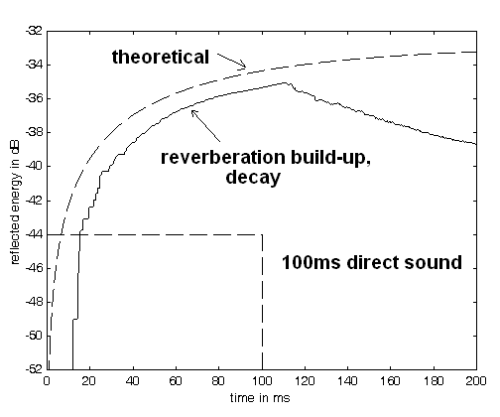
Figure 4 Build up and decay in a hall half the size of BSH. The RT decreases to about 1.1s, from a value of 2.2s in the full size BSH model. Note as expected the onset time delay has also decreased a factor of two. But notice the D/R has decreased, from about minus 6dB to minus 8.5dB. In spite of the far lower RT, these changes cause a significant reduction in clarity and an increase in perceived distance to the source. An audience member can compensate by buying a more expensive seat – but the number of good seats decreases considerably.
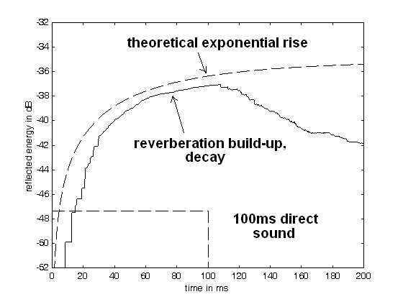
Figure 5 A similar diagram for an existing small shoebox hall, of about 350 seats. The measured RT is 1.0s. The D/R has is -10dB, and the onset delay is smaller than figure 4. This hall is reasonably articulate in the middle seats on the floor. Closer to the stage the sound is loud and harsh. Further back the sound is blurred, with poor separation between notes and instruments.

Figures 4, and 5 show the folly of assuming that because a shoebox shape works well (sometimes) for a large hall, the shape is ideal for a smaller hall. Unlike our expectation, the D/R has decreased, even though the RT has decreased. Removing all possible absorption to bring the RT back up to 2 seconds will further decrease the D/R and make the situation worse. The D/R decreases because sound builds up quicker in a small hall, so a note of a certain length creates a stronger reverberation. The hall has become smaller by some factor, but the tempo of the music remained the same. The heads of the listeners did not get smaller, and their brains did not work faster either.

Alas, the folly is entrenched. A great many small shoebox halls are being built. The good news is that some of them sound better than one would expect from these models. The best drastically increase the cubic volume per seat – becoming essentially a large hall with a small number of seats. When the extra volume is above the listeners, the sound can be pretty good. While I was in Helsinki I visited a ~400 seat small hall. The hall was large and high for the number of seats it contained. The RT was ~ 2.0 seconds, as specified by the client – but in spite of this many of the seats sounded at least OK. The best sound was in row 4. In row 8 it was barely OK. In row 11 it was muddy and blurred – and in row 13 (there were 14 rows) it was good again. Eckhard Kahle and I independently agreed on these assessments, which were confirmed by binaural recordings. ( Most likely the sound gets better further back because there is less reflected energy coming from the rear. ) In the violin-piano concert I heard the two musicians played as close as possible to the audience, so the large reflecting stage area had little effect. A concert involving larger forces would likely dissolve into mush.

4.3. Good small halls exist

One of the best small concert halls is in Boston: Jordan Hall of the New England Conservatory, 1200 seats, built in about 1910. This hall is half of an octagon in shape, with a very high ceiling. The audience surrounds the stage, on the floor and in a single balcony. The RT is about 1.3s occupied. Because the audience is closer to the stage than they would be in a shoebox, and because there is a lot of extra volume on top, nearly every seat combines excellent clarity and localization with a beautiful sense of surrounding reverberation. While ideal for chamber music, small orchestras also sound wonderful. The hall is small but similar to the Theatre de Colon. It fulfills Krokstad’s ideal – it maximizes audience involvement.

5. THRESHOLD DATA

Thresholds for the onset of localization were measured using a binaural hall model and a source signal that emulated a cello, playing notes of a scale with a rise-time of 20ms, a fall time of 100ms, a duration of 200ms, and a gap between notes of 100 or 200ms.

Figure 6 Top – thresholds for the detection of localization as a function of the time delay between the direct sound and the build up of reverberation to an energy equal to the direct sound, and as a function of the D/R. Note the threshold decreases as the delay increases. Bottom – when the gap between notes decreases, the threshold increases.

Figure 6 shows some thresholds for localization of a cello tone. The threshold is the lowest for the 1000Hz band, and is very high for the 250Hz band. This shows the importance of maintaining a high D/R above 1000Hz in a good hall. How can this be done, particularly if a client has specified a constant reverb time of 2 seconds? The trick is to reduce the reverberant level at these frequencies by clever use of frequency dependent reflections and diffusion. If frequencies above 1000Hz can be preferentially reflected back to the front of the hall where the direct sound is strong and absorption is high, the D/R in distant seats will be raised. This is the magic provided by coffered ceiling and wall surfaces in Boston, Vienna, and Amsterdam.

In the experiments described in section 7 of this paper we found that to obtain thresholds that matched subjectively the localizability of a string quartet we needed to reduce the gap length to 50ms. These thresholds will be published in a future paper.

6. BINAURAL MEASURES

The clarity of halls and stages changes dramatically when they are empty, and they are hard to measure when they are occupied. I believe this difficulty has contributed to the neglect of direct sound in the current literature. We need measures that analyze the same signals we do – music and speech – recorded with microphones with our natural hearing. The author uses binaural recordings made at his eardrums for the raw data.

Ideally a measure for distance and clarity should use the same mechanisms that the human brain uses to determine these perceptions, including a neural model. I have worked on two such measures, one for localization, and one for distance. Both measures take as inputs binaural recordings of a small number of instruments – ideally a solo instrument, actor, or singer. The recording is analyzed with a hearing model and azimuth and distance information is extracted. The percentage of time where such an extraction is possible becomes a measure of the space.

It is almost always possible to localize some sounds in an acoustic space. The brain is good at separating the direct component of a sharp click from the reverberation. Remember it takes time for reverberation to develop. A click is short enough that very little reverberant energy is generated, and the reverberant level is low.

But musical notes are usually not that short, and they tend to mask one another. The perception of localization relies on very brief inputs of real information. Typically only the onsets of sounds can be localized, and only if they have not been masked by previous sounds. So a measure based on the percentage of localized onsets makes sense.

My system for measuring localization has been previously described. [7] We find the IACC in overlapping 10ms segments of a musical signal, and plot 1/(1-IACC) in 1/3 octave bands. The result is a map of the D/R of the onsets of sounds as a function of time and frequency. The percentage of time these are over some threshold can be counted. We can also plot the Azimuth determined by this measure as a function of azimuth and frequency. This shows how consistent the azimuth is over frequency – also a measure of hall quality.
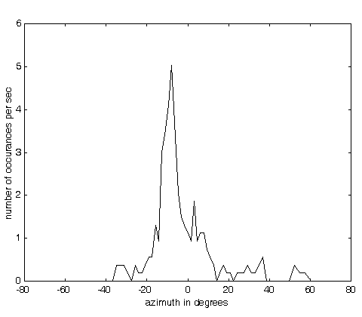
Figure 7: the number of times per second a note from a solo violin is localized in row 4 of the small hall near Helsinki. The indicated azimuth is correct – about 10 degrees to the left of center. The binaural recording was made with probe microphones at the ear drums of the author, and plays with startling realism with headphones calibrated the same way. A ~ 5 second segment was analyzed to make the graph.
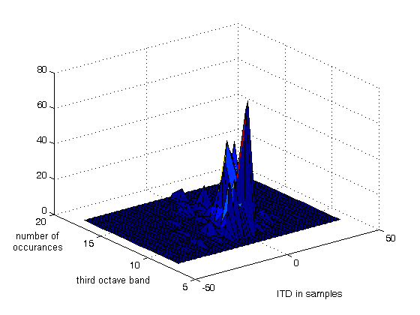
Figure 8 A surface showing the frequencies of maximum localization for the violin in figure 6. The major peak is for the 1000Hz 1/3 octave band.
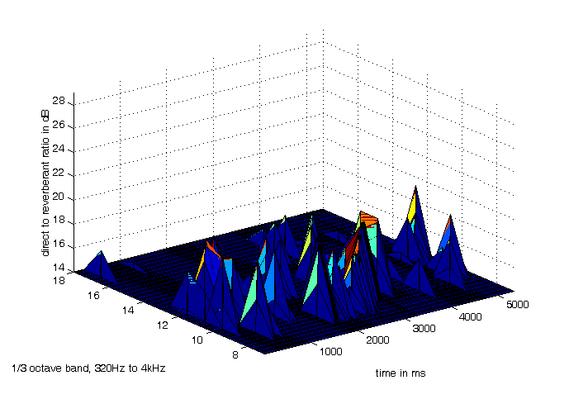
Figure 9 A time/frequency surface showing the peak in running IACC that occurs at the onset of each note of the violin in Figure 6. For a very short time the localization is quite clear.
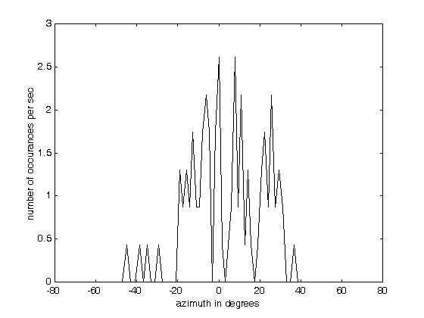
Figure 10 Number of localizations per second for the same violin in row 11 of the small hall in Helsinki. Note the small number of localizations, and the poor consistency of azimuth. Localization is very difficult, but sometimes possible, in this seat. The sound is muddy.

We can build a similar measure for distance, in this case using the concept of harmonic coherence. [6] Harmonic coherence is a monaural measure, which tests the degree to which harmonics of a pitched sound source are phase-locked to each other. This phase locking is highly audible, resulting in a sound described by Zwicker as “roughness”. The phase locking is destroyed by reverberation, and can be used as a measure. When the phases are locked the fundamental frequency is easily determined by rectifying critical bands. For these examples I plot the strength and frequency of the extracted fundamental as a function of time. All critical bands with significant fundamental are combined. Here I show sounds from opera singers binaurally recorded in Oslo.
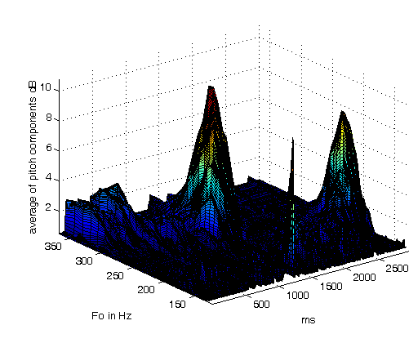
Figure 11 A strong baritone forcefully singing directly to the third balcony. The sound there is often muddy, but the fundamental pitch of this singer came through at the beginning of two notes. He seemed to be speaking directly to me, and I liked it.
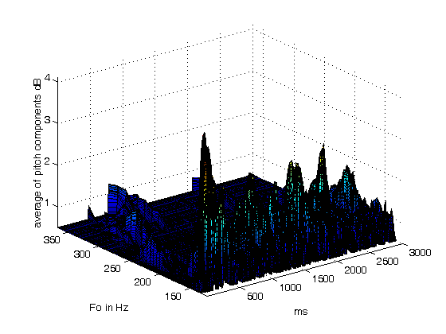
Figure 12 The king (in Verdi’s Don Carlos) on the other hand, in his wonderful solo aria, was not able to reach the third balcony with the same strength. The fundamental pitches are not well defined. He seemed muddy and far away. The pathos was muted.
7. A REAL-LIFE EXAMPLE
Through the generosity of the Longy School of Music in Cambridge, the help of Steve Barbar of Lares Associates, and the firm Acentech, I was able to perform a week-long experiment in the small hall shown in figure 5 and 13.
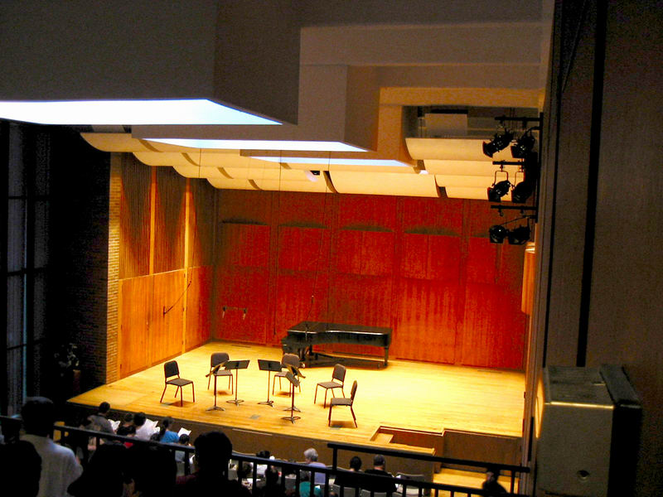
Figure 13 An existing small hall. Seating capacity about 350 with a single balcony. RT occupied 1.0s at 1000Hz. Note the highly reflective stage, floor and ceiling elements. Sound in the first few rows was loud and harsh, sound in the rear half of the hall was non-localizable and muddy.
Many acoustic improvements had been proposed over years. All of them involved removing absorption from the hall and/or installing additional reflectors on stage.
The data in this paper suggests something quite different. If we absorb as many first-order reflections as possible we can increase the D/R, and at the same time we can increase the time delay between the direct sound and the build-up of reverberation. Everyone involved (except Steve Barbar) was skeptical, to say the least.
But we added about 700 ft^2 of absorption to the stage, effectively increasing the directivity of the musicians by about 2dB. In addition we added some absorptive panels to the side walls to decrease the strength of the first-order lateral reflections above 1000Hz. These modifications could be taken in or out in about 5 minutes, allowing (almost instant) A/B comparisons. We also added a small LARES acoustic enhancement system with 25 loudspeakers.
Many faculty and students played in the hall during the experiments, and all the sounds were recorded with three dummy heads, as Soundfield, and a close mike array on the stage.
The sound was dramatically better. Far from being put off by the absorption on stage, the students and faculty at the school were delighted. Several were sure we had found a much better piano. The middle registers were suddenly clear and better balanced. Soloists playing together with the piano no longer had to force to be heard, and the same was true for solo violin. The difference to the audience was equally great. The muddiness was gone. The sound was more articulate, better balanced, and rich.
The LARES system was adjusted to a minimal value. We simply used it to bring the occupied RT back to the previous value of about 1.0 seconds at 1000Hz. More was not needed. We also turned it off frequently to see how the musicians reacted. They found the effect subtle. Nearly all the improvement was due to the absorption – and the absorption on stage was the most effective. The result was amazing to most of the listeners. The idea that adding absorption to a small hall which already had an RT of 1 second or less could improve the sound was unheard of. But the result was clear to everyone. We also tried adding hard reflectors behind the piano, creating a mini shell. The sound in the audience was poorer.
The overall result was not unexpected to me. The model work predicted it. But there was an easily available example. In the same building as Jordan hall is Williams Hall, a small recital hall of about 350 seats. Williams is almost cubical, with about 1.3 times the volume of the hall at Longy. The stage is old fashioned, made fully absorptive with heavy drapery around the back walls and above the proscenium. The sound for a chamber group has been wonderful for nearly 100 years. No one is thinking of changing it. But it seems to have been forgotten by acousticians.
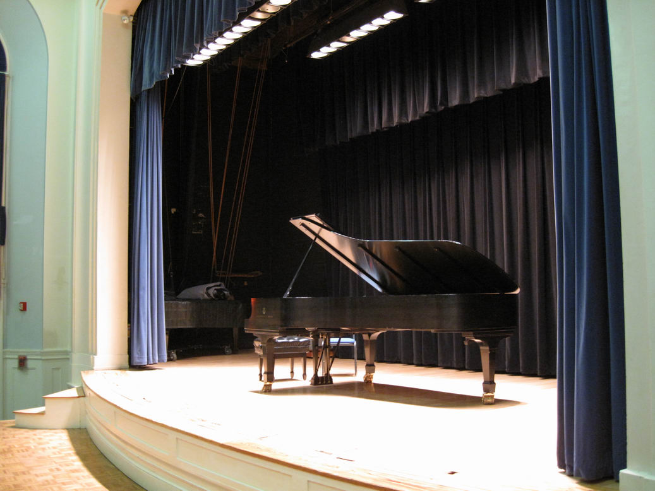

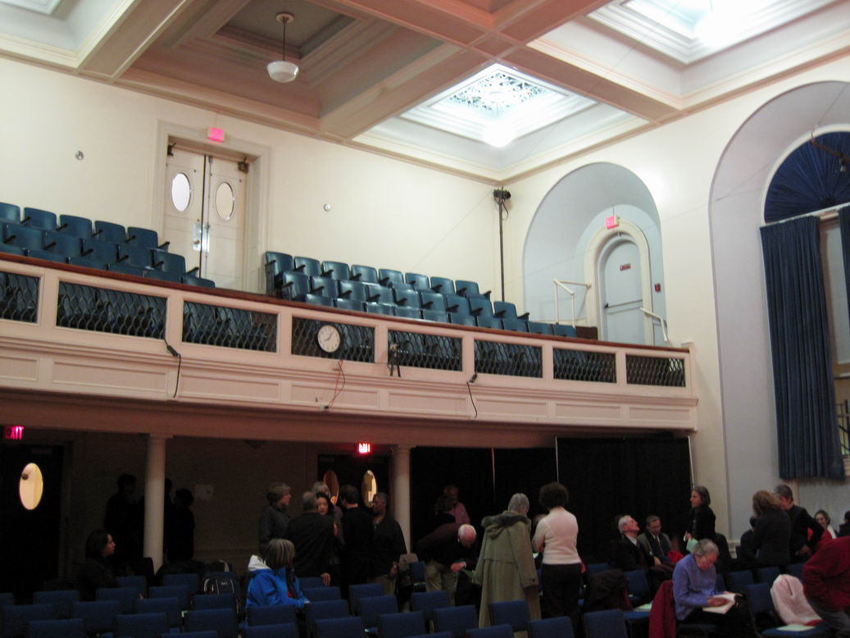
Figure 14 Williams Hall at New England Conservatory. There are about 350 seats. Note the fully absorptive stage, coffered ceiling, and the relatively close seating of the audience.
8. ACKNOWLEDGEMENTS
The author wishes to thank Steve Barbar of LARES Associates for his tremendous support of this project, the Longy School of Music and their president Karen Zorn for their encouragement and support, the essential organizational help of my wife Harriet, and many friends who pitched in to do the work.

7. REFERENCES
- Gardner, William “Reverberation Level Matching Experiments” Proceedings of the Wallace Clement Sabine Centennial Symposium, Cambridge MA 5-7 June 1994. (a copy of this paper is on the author’s website.)
- Griesinger, David “ The effective loudness of running reverberation in halls and stages” – ibid. A similar paper “How Loud is my Reverberation” is on the author’s web page.
- Griesinger, David “The psychoacoustics of apparent source width, spaciousness and envelopment in performance spaces” Acta Acustica Vol. 83 (1997) 721-731. ( this paper is on the the author’s web page)
- Barron, Michael “Auditorium Acoustics and Architectural Design” E&FN SPON 1993

[5] Griesinger, David “Frequency response adaptation in binaural hearing” presented at the AES conference in Munich, May 2009 A previous version of this talk is on the author’s web page.

[6] Griesinger, David “Pitch Coherence as a Measure of Apparent Distance and Sound Quality in Performance Spaces” Presented at the IOA conference on Hall acoustics, Copenhagen May 2006. This paper is on the author’s web page.

[7] Griesinger, David “Lecture Slides from the RADIS conference, Japan 2004.” A link to these slides and to the audio examples can be found near the top of the author’s web page.

