Phase Coherence as a Measure of Acoustic Quality, part three: Hall Design
David Griesinger
Consultant, 221 Mt Auburn St #107, Cambridge, MA 02138, USA
PACS: 43.55.Fw, 43.55.Mc, 43.66.Ba, 43.66.Hg, 43.66.Jh, 43.66.Qp
ABSTRACT
The first of these three papers described the physics and physiology that enables humans to detect nearly instantly the apparent closeness of a sound source. The second described some of the author’s experiences that led to the recognition that engagement is a vital aspect of music and drama, and is too often absent in modern performance venues. In this section we describe the features of well-known venues that manage to combine engagement and reverberation. In order of importance these features are size, shape, stage design, and the presence of frequency dependent scattering that reduces the strength of reflections and reverberation at frequencies above 700Hz.

Introduction
The previous two papers in this series have been concerned primarily with the acoustic properties that encourage the engagement of a listener in a performance, either of drama or of music. But reverberation also plays a vital role in live performances – and the properties of halls that provide reverberation seem to conflict with the properties that provide engagement. The loudness of music in a hall also plays a role. Part three of these talks discusses the features of great halls that successfully provide both engagement and reverberation at the same time over a wide range of seats. Methods will also be presented that can be used to increase the number of engaging seats in existing halls and opera houses – and to improve the audibility of reverberation when it is lacking.
As engagement has been previously discussed, we will first consider the perception of reverberation and envelopment. We will find that engagement and reverberation are not opposites of each other. Both require the perception of the direct sound to be optimally heard. The issue of loudness will be considered separately.
REVERBERATON AND ENVELOPMENT
Reverberation in recorded music
Reverberation is technically the sum of all the sound that does not travel directly to a listener. The most common measure of reverberation is the reverberation time (RT) the time it takes for sound to decay 60dB. But the perception of reverberation is more complicated than can be expressed with a single number. Recording engineers of both classical and popular music use reverberation as one of the essential components of a good recording, and carefully add it to sound mixes using a variety of commercial digital equipment, or with special purpose microphones in recording venues.
In all such recordings it is the level of the reverberation relative to other elements of the mix that is the most important parameter, not the reverberation time. I have measured the amount of reverberation in many classical mixes, and have made experiments where good acousticians add reverberation to a mix, and then measure the amount used. In all cases the answer is the same. In classical mixes the total energy in early reflections and late reverberation is between minus 4dB and minus 6dB of the total energy in the direct sounds. This means that in recordings – which in some sense represent an ideal representation of a performance – the D/R is between +4 and +6dB. This level of reverberation can be considered ideal because recordings can be A/B compared to each other, and customers can choose which ones to play, and which to leave to languish. Engineers – aided by some very critical conductors in the playback room – have learned what kind of sound does the music the most justice.
This is the range of D/R that was explored by Barron and others in their studies of spatial impression. The author knows of NO successful classical or popular music recording where the D/R is less than -3dB. Very few seats in a concert hall have D/R ratios this high. Recording engineers add reverberation – or arrange their microphones to record reverberation – at levels just strong enough for it to be frequently, if not continuously, audible while the music is playing. There is no point of reverberation if you cannot hear it, and more than enough reverberation muddies the recording.
Recordings have become the norm for music listening, and opera performances such as the New York Metropolitan Opera HD broadcasts are seen by far more people than the live events. The sound of the MET broadcasts in most theatres is harsh, direct, and nearly devoid of reverberation. (Movie music in the same theatres is more reverberant than the operas – but movie dialog is always dry.) The opera sound is not beautiful, but the dramatic experience is very powerful. The video image brings you close – sometimes too close – to the performers, and the sound makes them seem to shout in your face. The result can be overwhelming. The performance of “Salome” with the Finnish soprano Mattila was blood-curdling to this author. It was emotionally far beyond what I would have experienced from a balcony at the MET.
I also saw “Salome” in the State Opera House in Vienna. The sound was far superior to the broadcast in timbre, and also nearly devoid of reverberation. The Vienna Philharmonic can play very loud in that house! The result was highly engaging. In Vienna the visual distance was greater than the HD image – but it was still a powerful performance. Like it or not, audiences have come to expect, or will come to expect, a similar experience to the HD broadcast when they come to a live event. They will get it in the Staatsoper Berlin, or the Vienna Opera. I can’t imagine seeing or hearing “Salome” in an opera house like the Paris Bastille.
Stream formation – foreground and background
In recordings the direct sound is always strong enough to be perceived as separate from late reverberation. When this separation is possible the brain creates two distinct sound streams. The foreground stream contains the direct sound, the sound that provides information about pitch, timbre, and localization. The background stream contains the late reverberation from the direct sounds and environmental noise. This subject is extensively explained in [1].
The background stream has interesting properties. For example, you can only hear the background stream in the gaps between the foreground sounds, but the background is perceived as continuous, and often louder and more enveloping than the reverberation itself.
The brain can assign sounds to a background stream only if it is possible to detect a distinct foreground stream. When direct sound is not separable from reverberation the brain perceives both as a foreground stream, and analyses both as a single unit. This perception is very common in modern halls. The sound is muddy, reverberant, and not enveloping. Localization is poor for such a stream. Both the reverberation and what is left of the direct sound seem to come from the front of the listener, which typically matches the visual image. The listener can imagine he or she is localizing the instruments – and this may be true for occasionally for instruments that are highly directive – but the overall sound is muddy, and surprisingly not enveloping.
The bottom line is that a rich, enveloping reverberation cannot be perceived unless the direct sound can be separated from the late reverberation. Direct sound and reverberation are not inimical – they are both essential.
A FEW EXAMPLES
Although a small percentage of shoebox concert halls with a reverberation time of about 2 seconds have a good reputation, the success of a hall (of any shape) with the same reverberation time is not guaranteed. The opposite is proved by halls all over the world. We can glean some of the reasons some halls work better than others by looking at a few examples.
In [2] the author examines three shoebox halls of similar size and shape. A major difference is the design of the stage house. The stage of New York’s Avery Fisher hall is deep and low ceilinged, with no absorption besides the orchestra on the floor. There are multiple prompt internal reflections which add to the direct sound of the instruments, particularly those in the back of the orchestra. These instruments sound muddy and far away, although instruments in the front row, such as a violin soloist, have some engagement. But the engagement is lost as you move back in the hall. In the front of the first balcony the sound is muddy, not localizable, and not reverberant. It is simply unclear. The sound from the rear of the stage lacks clarity because of the reflections in the stage house. Why is there high engagement in the front of the first balcony in Boston, and not in New York? Why is the rear of the hall not enveloping?

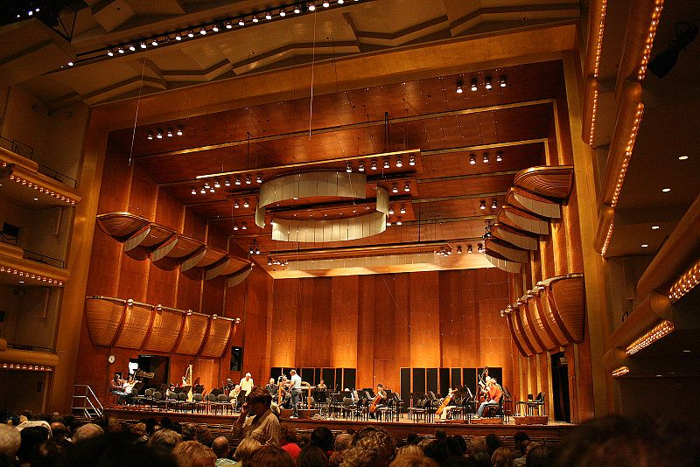

Figure 1: Avery Fisher Hall, New York City. Note the deep, low ceilinged stage house, with nearly parallel side walls. These surfaces trap sound inside the stage, which scrambles the phase coherence of the harmonics from instruments in the rear of the orchestra. The ceiling of the hall is basically flat, as are the side walls.
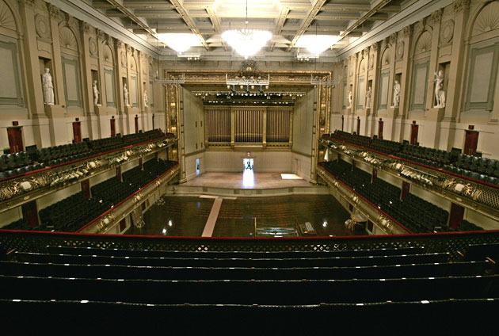

Figure 2: Boston Symphony Hall. The stage house is high, wide, and shallow, with sloping side walls and ceiling. Reflections from these surfaces are directed into the hall, and multiple reflections do not occur within the stage house. Instruments in the rear of the orchestra have equal clarity as instruments in front. Notice the coffers on the ceiling, and the niches along the side walls.
The stage in Boston does not capture the sound from the orchestra. It throws it out into the hall. This gives the orchestra both clarity and power. Instruments in the rear of the orchestra are heard with clarity, as the phase coherence of the harmonics is not scrambled by multiple prompt reflections. The coffered ceiling and the niches on the side walls are wonderful. They have the effect of sending frequencies above 1000Hz back to the front of the hall, effectively increasing the D/R ratio for seats in the rear. As a consequence the hall is engaging over a wide range of seats. The occupied reverberation time is only about 1.8 seconds, and yet the hall is perceived as both reverberant and enveloping.
The walls below the first balcony are not coffered, and there are reflections from them into the rear of the stalls. These reflections are augmented by a second set of reflections from the under balcony surface to the side walls and then into the stalls. The combination of the two reflections makes seats in the stalls further back than row W less engaging than seats more forward in the hall.

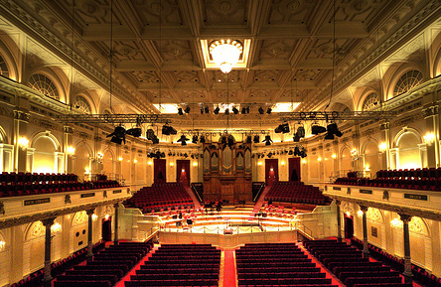

Figure 3: The Amsterdam Concertgebouw. The Concertgebouw is square in plan, and there is no stage house. The average distance from the orchestra to a listener is smaller than it is in Boston. There are no reflections from the wall behind the orchestra, as they are absorbed by the audience and the organ. The ceiling is coffered, as in Boston, and the reflections from the side walls arrive later than they do in Boston. All these factors combine to give the hall unusual clarity. The reverberation time is longer than in Boston, and the late reverberation is strong, as there are a great many surfaces that reflect the sound upward above the audience, where it can take its time to get back down. The high late reverberation level, combined with the clarity of the direct sound, give a rich sense of envelopment throughout the hall.
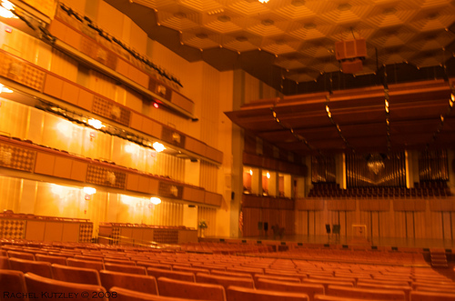

Figure 4: The Kennedy Centre, Washington, DC. Note the flat canopy over the orchestra, and the rippled – not coffered – ceiling in the hall. No niches or coffers adorn the side walls. The audience on the stage absorbs some of the sound that would otherwise go to the hall. The sound in the first half of the stalls is not as loud as Boston, but reasonably clear. The author has not heard the sound further back.
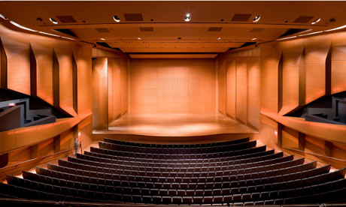

Figure 5: Alice Tully Hall, New York City.
Alice Tully is a wide fan – not intrinsically bad – but note the flat ceiling, the nearly parallel side walls on the stage, the flat ceiling over the stage, and its nearly parallel alignment to the floor. This stage house traps sound, adding prompt early reflections to any instrument with a non-directive radiation pattern, such as piano or woodwinds. There are no coffers or niches. The hall is also physically large for a chamber music hall, with a large average seating distance. Musicians are visually and sonically far away. Not a very promising place for a violin-piano performance, or a string quartet. You need to get a seat up close.
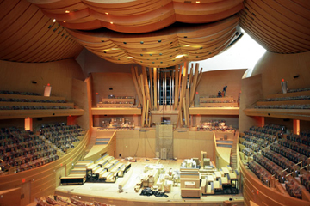

Figure 6: Disney Hall, Los Angeles.
Disney Hall is a vineyard hall, not a shoebox. There is no stage house, but reflections from the rear of the orchestra are directed into the stalls by the wall behind the orchestra. This adds a prompt, strong early reflection to the direct sound. This reflection is not sufficient to eliminate engagement, but it is a major component of the sum of all the early reflections. Note that all the ceiling surfaces are devoid of frequency-dependent scattering. They direct the first reflections from the orchestra down into the audience, where they add to the prompt reflection from stage wall, and form a sum sufficient to scramble the phases of the direct sound in the first 100ms. These reflections are then absorbed by the orchestra and audience, so all this energy does not contribute to late reverberation. The result is very strange. Even in the middle of the stalls the orchestra seems far away. At the same time late reverberation is almost inaudible. It is unusual that a hall with a two second reverberation time should sound so dry – but this shows the vital importance of both the low late reverberation level, and the lack of a separately perceived direct sound.
I heard a performance of “Le Sacre du Printemps” in Disney Hall from a seat in the middle of the stalls. As mentioned above, the sound was distant, relatively quiet, and might be best described as “nice”. I was surprised by the sense of distance. I expected at least some engagement in that seat. The next week I was in Berlin, tuning the Staatsoper. As luck would have it, after the tuning the Staatscapella performed “Printemps” with the Berlin Staatsoper Ballet. I happened to record both the performance in Disney and the performance in the Staatsoper with the same equipment. The Staatsoper was 10dB louder than Disney Hall. The sound from the centre of the first balcony in the Staatsoper was anything but “nice”. It was wild, orgasmic, gut wrenching. This is the music that started a riot in Paris when it was heard in the dry acoustics of the Theatre des Champs-Elysees. No riot was started by the performance in Disney. The audience politely applauded.

THE MAIN POINTS OF PART THREE
The ability to distinctly hear the Direct Sound – as measured by LOC or through the analysis of a binaural recording – is a vital component of the sound quality in a great hall.
The ability to separately perceive the direct sound when the D/R is less than -3dB requires time. When the d/r ratio is low there must be sufficient time between the arrival of the direct sound and the build-up of the reverberation if engagement is to be perceived.
Hall shape does not scale. Our ability to perceive the direct sound – and thus localization, engagement, and envelopment - depends on the direct to reverberant ratio (D/R), and on the rate that reverberation builds up with time. Both D/R and the rate of build-up change as the hall size scales – but human hearing (and the properties of music) do not change. Reducing the scale of a hall by a factor of two will only be successful if the pitch and tempo of the music increases a factor of two, and the speed of our neurology also increases a factor of two. This does not happen!
A hall shape that provides good localization in a high percentage of 2000 seats will produce a much lower percentage of great seats if it is scaled to 1000 seats. We need to bring the average seating distance closer to the musicians if a small hall is to be both reverberant and engaging. We also need to reduce the reverberation time.
Frequency-dependent diffusing elements are often necessary, and they do not scale.
The audibility of direct sound, and thus the perceptions of both localization and engagement, is frequency dependent. Frequencies above 700Hz are particularly important. Frequency dependent diffusing elements can cause the D/R to vary with frequency in ways that improve the audibility of direct sound. This works because such elements reduce both first order and higher order reflections at high frequency. The LOC equation is sensitive to all reflections in a 100ms window, as is my neurological model for pitch, timbre, and azimuth detection. 100ms will include many second and third order reflections, especially in small halls.
The best halls (Boston, Amsterdam, and Vienna) all have ceiling and side wall elements with box shape and a depth of ~0.4m. These elements tend to send frequencies above 700Hz back toward the orchestra and the front of the stalls. Listeners in these locations appreciate the increased spatial impression, and engagement is not affected because the direct sound is strong. But the audience and musicians in these positions absorb these reflections. (The absorption only occurs in occupied halls – so the effect will not be detected in unoccupied measurements!) The result is a lower reverberant level above 700Hz in the rear of the hall. This increases the D/R at high frequencies for the rear seats, and improves engagement. Replacing these box shaped elements with smooth curves or with smaller size features does not achieve the same result.
Some evidence of this effect can be seen in RT and IACC80 measurements when the hall and stage are occupied. Measurements in Boston Symphony Hall (BSH) above 1000Hz show a clear double slope that is not visible at 500Hz. Although BSH is a large shoebox, the hall has high engagement in at least 70% of the seats.
Thanks to Larry and Dana Kirkegaard I have some very rare measurements of BSH when the hall and stage were fully occupied. The measurements were made with a series of large balloons, so the impulse responses are not as sharp as I would like. But they show a clear double slope in the rear seats at frequencies above 1000Hz.
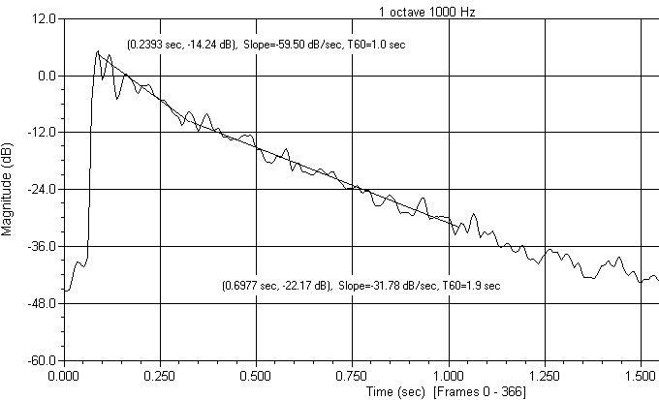

Figure 7: 50ms window-integrated impulse response of Boston Symphony Hall with occupied hall and stage, 1000Hz octave band. The source was in the middle of the violin section, the receiver was in the front of the first balcony – nearly 100ft from the source. Note the clear double slope. The RT for the first 10dB of decay is 1.0 seconds. The RT of the later decay is 1.9 seconds. The side wall and ceiling reflections have been significantly attenuated at this frequency. This is Leo Beranek’s favorite seat. It provides excellent localization, engagement, and envelopment.
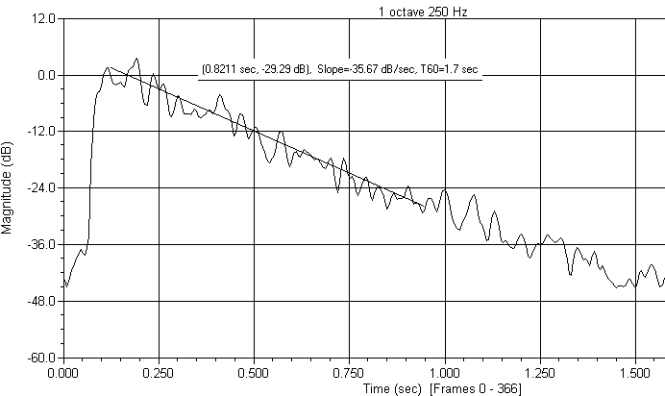

Figure 8: The same impulse as figure 1, but in the 250Hz octave band. Note that the double slope is not visible. The direct sound has been overwhelmed by reflections and reverberation – as one would expect at so great a distance.
The double lateral reflections from the side walls are a problem for the seats in the stalls, as there is no coffering on that surface, and the ceiling below the first balcony is planar and hard. But the coffering on the main ceiling keeps the early reflections above 700Hz weak enough that there is good localization and engagement to at least row T on the floor. Localization and engagement are much poorer in seats just after the cross-isle, row W and further back. In my opinion the hall would be improved by adding 1” absorptive panels to the underside of the first balcony in areas that reflect to the rear of the stalls. This would be inexpensive to try!
Localization and engagement are restored in the front of the first balcony because the primary reflection from the side wall is blocked by the side audience. There is a secondary reflection off the ceiling below the second balcony to the first balcony side wall – but it is not strong enough to inhibit localization and engagement. Although the instruments subtend smaller angles in the front of the balcony than they do in the centre of the stalls, the localization of the woodwinds is better in the balcony. They do not play on risers.

SIZE AND SHAPE
The most important factor that contributes to both engagement and to the beneficial perception of reverberation is the size and shape of the hall.
We have made the point that engagement requires that a sound be perceived as close to the listener, even if the physical distance is large. What happens if both the sonic and the visual distance are close?
The author has had the experience of hearing a fine string quartet from a distance of only two meters. The clarity was fantastic – in fact, it was in the process of marveling about how well I could hear the inner voices that I realized some of the essential features of the sound detecting mechanism described in part one of this talk. But I do not usually sit this close. Shortly thereafter I heard another fine quartet from the middle of the stalls in the auditorium at the Metropolitan Museum of Art in New York City. The sound was reasonably clear – but not very loud. The quartet seemed lost in the large stage. The sound was not very exciting. The musicians were physically too far away for this music.
There may be an ideal distance from which to hear various kinds of music. It is probable that a space similar to the historic spaces in which the music was first performed might be a guide. But one should be cautious about the current condition of these spaces. Many of these spaces were far less reverberant in the past, filled with fabric since removed, and richly dressed audiences. Halls need to be larger these days to pay the bills.
But it is possible to build large venues which bring the audience closer to the musicians. The Concertgebouw in Amsterdam does this for a large orchestra. It is one of the halls at the top of Beranek’s list. I heard Anner Bylsma play the Bach cello sonatas from a seat near the rear of the hall. The sound was clear, localizable, reverberant, and engaging.
Asbjørn Krokstad, Norway’s best known acoustician and a noted conductor, gave a provocative lecture in Oslo about why current concert halls are not attracting younger audience members. He suggested that halls need to be engaging, not just nice. I was very excited – he had given me the word to describe the perception I had been attempting to communicate. At the end of the lecture he showed a picture of the Teatro Colón in Buenos Aires, Argentina. “Is this the concert hall of the future?” he asked.
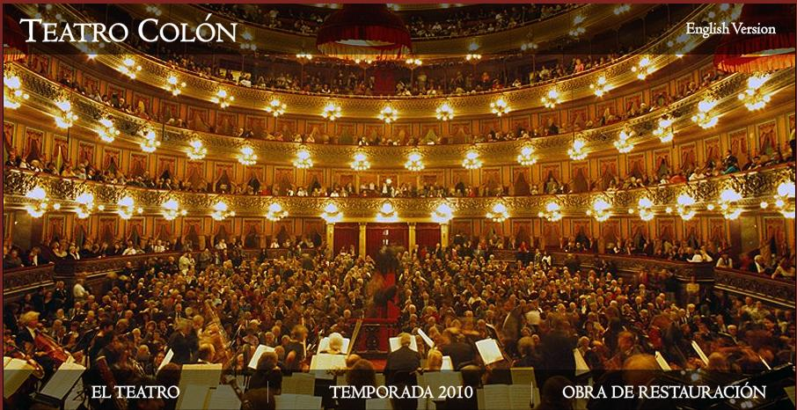

Figure 9: Teatro Colón in Buenos Aires, Argentina. This hall is not a shoebox. Beranek classifies it as a large opera theatre with a semi-circular shape, and four tiers of balconies. The theatre is renowned as a concert hall. Notice that this is how it is being used in the picture above. The essential feature of this hall is that the average distance of a listener is close to the orchestra. The cubic volume needed for good late reverberation is provided by a high ceiling, which is also high enough that the ceiling reflection into the stalls has enough time delay to be relatively weak. (The strength of a reflection relative to the direct sound decreases proportionally to the extra distance that is travelled.)
The Teatro Colón holds 2,487 seats. Beranek classes it as “one of the beautiful large opera houses in world,” and not as a concert hall, so it does not appear in his ratings for halls. As an opera he says it is better than the Metropolitan in New York, and as a concert hall it is “surprisingly satisfactory.” It is not a shoebox, it is not a vineyard, its reverberation time is 1.8 seconds, and yet Beranek reports that he has never heard a conductor who did not say that the Teatro Colón is one of the best halls in the world to conduct in, and to listen in. I have not heard it – but it is reported to be perceived as both engaging and reverberant in most of the seats. Orchestras love playing there. Why has it not been widely copied?
MEDIUM-SIZED (700-1500 SEAT) HALLS
Boston is blessed not only with one of the three halls rated “excellent” in Bernaek’s surveys, but with two of the finest chamber music halls that I know. Neither of the chamber music halls is a shoebox, and neither has a reverberation time over 1.5 seconds. Both halls are semi-circular in shape for the audience, with a single balcony, and an under balcony parquet. The balconies are spaced relatively high above the parquets, giving ample space for reverberation from the high ceilings to reach the audience members sitting below the balcony.
Jordan Hall at New England Conservatory
If you are a chamber musician and can attract a large audience, Jordan Hall is your Mecca. Boston Symphony is too large. The average audience member is too far from the stage to hear a string quartet, or an instrument-piano recital. Jordan is intimate. The average seating distance is close enough that the direct sound is strong and engaging in almost every seat, and yet the reverberation is almost always audible and rich. The reverberation time is about 1.5 seconds if you don’t manage to sell out the hall, dropping to about 1.3 seconds when the hall is sold out – which is often the case.

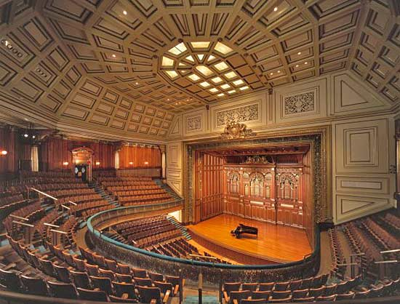

Figure 10: Jordan Hall at the New England Conservatory, Boston. (1020 seats) The hall is semi-circular in shape, with a single large balcony. This arrangement shortens the average seating distance compared to a shoebox hall. The high ceiling and ample volume above the second balcony provides plenty of resonance. The stage house is deep, with parallel walls and a ceiling that is almost parallel with the floor. Instruments in the stage house lose the wonderful clarity this hall provides when the musicians are in front of the proscenium. The hall is in near constant use – and expensive to rent! It is known all over New England, and through the radio show “From the Top” it has become known throughout the United States.
The only real problem is the stage house, which has the ability to add enough multiple reflections to muddy the sound of those foolish enough to venture deep into it. Knowledgeable musicians avoid it.
Sanders Theatre, Harvard University
Harvard’s Sanders Theatre is almost identical to Jordan in size, shape, and seating capacity. Sanders has no stage house, so the clarity is excellent regardless of where musicians choose to play. The stage platform is large enough that the Boston Symphony used to perform a regular concert series there. Cambridge audiences (including me) were disappointed when the series moved to Boston. The clarity of the sound is very good throughout the hall. Like Jordan, Sanders is popular, and expensive to book. The audience area and side walls are built of old fashioned tongue-and-groove panelling, which soaks up the bass. Most musicians prefer Jordan for this reason. This problem would be simple and inexpensive to correct with electronic acoustics, but so far Harvard has resisted.
SMALL HALLS
The smaller the hall the more difficult it is to combine resonance and engagement at the same time. The problem is that in a small hall reverberation – whether in the form of early reflections or late reflections – builds up very quickly with time. As described earlier, the brain needs time to separate the direct sound from the reflections that follow. The time needed is dictated by human physiology, and not by the size of the hall. Human physiology also dictates that the sense of reverberance and envelopment that audience and musicians desire arises from reflections that arrive at least 100ms after the direct sound. In small halls the reverberation time is by necessity lower than in large halls, and the sound has decayed substantially before it can be heard as reverberance.
Since engagement is subconscious, and reverberance is not, acousticians usually advise that small halls be made as reflective as possible. This increases the reverberation time, and thus the resonance. But removing absorption will always raise the strength of the early reflections, and raise the total reverberant energy. The result will be even poorer clarity and engagement. There are solutions to this conundrum – but again they again require that we give up some deeply held myths.
Williams Hall, New England Conservatory.
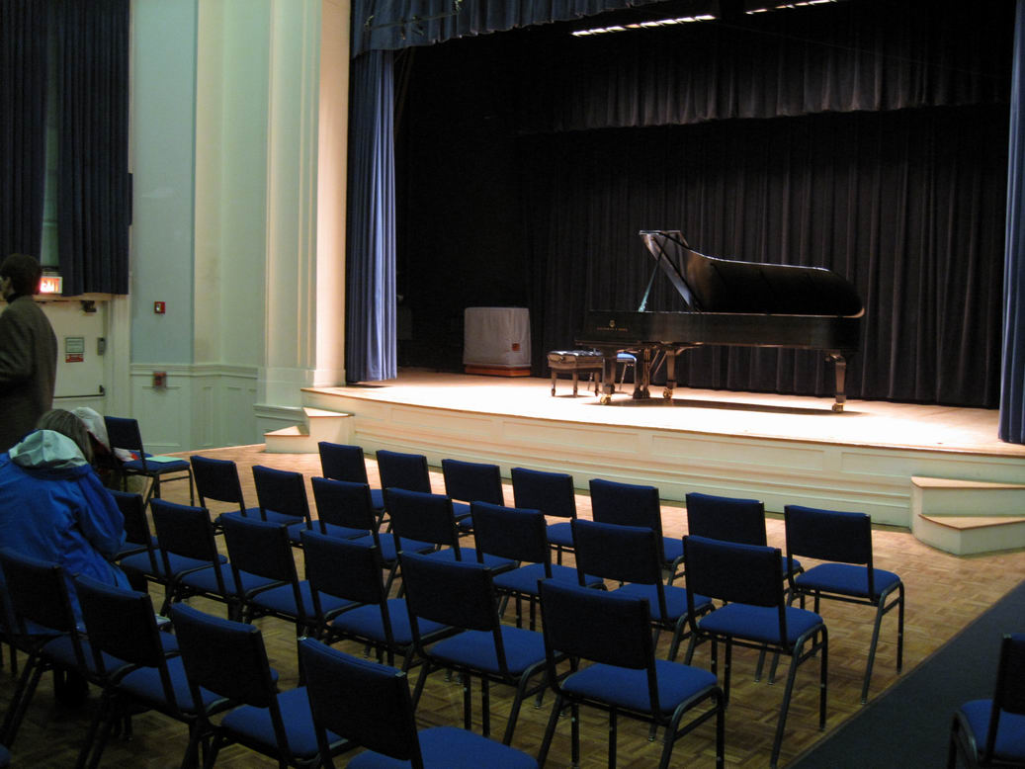

Figure 11: Williams Hall, New England Conservatory. Williams is a small recital hall of about 350 seats. It is square in plan, with a large single balcony. The ceiling is high and coffered, and reverberation time is long, especially when the hall is only partly full. This is the usual condition for student recitals. But the clarity for instrument-piano recitals is surprisingly good.
Why does Williams succeed in combining reverberation and clarity in a small hall? Take a look at the stage! How many modern recital halls surround the musicians with thick curtains, and hang a curtain in front of the proscenium? Who remembers the good old days when Carnegie Hall in New York had similar adornments? How many people with long memories wish the fabric would return?
The curtains behind the stage and in front of the proscenium absorb sound energy that would otherwise overwhelm the direct sound. Effectively the direct to reverberant ratio has been increased by 3dB or more by the curtains. And the proscenium curtain acts as a filter – low frequencies are not absorbed. High frequencies, which will reduce clarity, are absorbed. The absorbed sound is not missed in a small hall. Such halls are almost always too loud when modern instruments are played. Nine-foot grand pianos make an uncomfortable amount of sound when played in a salon or a recital hall.
A few halls that need work
As in most cities, there are many halls in Boston that do not work as well as the two described above. Most have a shoebox shape. I have been to concerts in many of them. In most cases the clarity is adequate in the first few rows, but the sound rapidly becomes muddy as you move back. They are generally too loud, especially with a student orchestra. They need not remain this way. In most cases the clarity could be greatly improved by simple modifications such as absorption in the stage house – but the current myths about the necessity of hard surfaces behind musicians prevents this from being tried.
Figure 7 shows the effectiveness of coffers and niches in increasing the D/R ratio in areas of the hall that would otherwise suffer from poor engagement. But these frequency dependent structures are not the only ones that can be used.
FREQUENCY DEPENDENT CANOPIES
Tanglewood Music Shed, Lenox Massachusetts
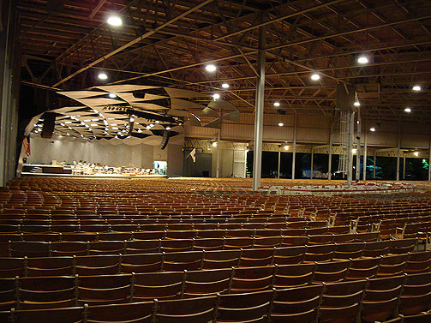

Figure 12: View of the canopy over the orchestra in the Tanglewood Music Shed. The canopy consists of open and closed sections of equilateral triangles of variable size. The canopy acts as a filter, directing high frequencies down into the orchestra and the first few rows of the audience, and letting the low frequencies into the upper reaches of the hall, where they have ample time to bounce around before coming back down. The high frequencies absorbed by the orchestra and audience do not contribute to late reverberation, thus raising the D/R above 1000Hz in the middle and rear of the hall.
The addition of the canopy to the Tanglewood Music Shed successfully changed the sound from impossibly muddy to clear and engaging for a wide range of seats. Such semi-open canopies (clouds) are relatively common in halls, but the people who design them usually do not think of them as ways of reducing the level of high frequency reverberation. The Berlin Philharmonie contains them, supposedly to let the orchestra hear itself better. But as in Tanglewood, a major effect is to increase the D/R above 500Hz in the rest of the hall.
Davies Hall in San-Francisco also has a canopy made of plastic panels. I have been told they were added to help the musicians hear each other – but they are also useful to some of the audience. In Davis Hall the plastic panels direct sound down into the orchestra and into the stalls. To my ears they do not improve the sound in the stalls, which seems loud and harsh, devoid of reverberance and envelopment. Perhaps the reflections provided by the panels are strong enough to mask the direct sound. But the sound in the dress circle and balcony is wonderful! With the improvement in D/R provided by the panels the clarity is excellent, and there is sufficient reverberant energy to provide good envelopment. A canopy like the one in Tanglewood or Berlin might do wonders for Disney Hall.
LOUDNESS
The phase coherence of upper harmonics is not the only factor that influences engagement. Loudness also demands attention. In classical acoustics loudness – or G – is inversely proportional to the total absorption, which is typically proportional to the number of people. So small halls are likely to be too loud, and large halls are likely to be too soft – unless the size of the orchestra is adjusted to match the hall.
Size, shape, and stage absorption can come to the rescue. Bringing the audience closer to the musicians in a large or medium sized hall – like Jordan Hall or Teatro Colón - increases the strength of the direct sound and the loudness. Adding volume above the audience increases the delay of the reverberation, making it more audible without compromising engagement. When a hall is perceived as too loud and too muddy, adding stage absorption can reduce the loudness and restore clarity. Whatever late reverberation the hall can provide becomes more audible.
ELECTRONIC ARCHITECTURE
In small and medium sized halls – and in most traditional opera houses –sometimes the only way to achieve the ideal balance between clarity and reverberation is the careful use of electronics. The success of some of these systems has been demonstrated in halls and opera houses around the world. The author recently substantially updated his algorithms. The latest versions increase the late reverberation time transparently, with no effect on clarity.
But not all electronic systems work well, and the idea of electronics in classical music halls is often resisted. There are two essential requirements for a successful installation. The first is that the hall must already have excellent clarity and engagement. Increasing the reverberation time of a hall that has too many prompt reflections will only make matters worse, and give electronics a bad reputation. Lack of clarity must be corrected before the electronics are used. With careful adjustment electronic enhancement sometimes can successfully augment the direct sound. Typically this works in the nether regions of a large hall, where the direct sound itself has become too weak to be audible. It does not work in a small hall where there are too many prompt reflections. The electronic reflections just add to the mess.
Adding absorption to the stage and side walls of a small hall can improve engagement, but it will invariably reduce the reverberation time. The change will probably be welcomed by the audience, who will hear greater clarity, and the remaining reverberation will be more audible. But the performers, who have plenty of direct sound and rely on late reverberation to judge their loudness and balance, will not be happy. We have found that a minimal enhancement system can add just enough late energy to restore or slightly increase the reverberance on stage and in the hall. Everyone will be delighted.
The other requirement for a successful system is that the microphones that pick up sound from the musicians must be placed close enough to receive primarily direct sound. Some electronic enhancement systems work by picking up sound in multiple positions in the hall, amplifying and delaying it a bit, and reproducing it somewhere else. These systems reduce the effective absorption of the hall, raising both the early and late energy. The reverberation time goes up – but the sound being amplified is already muddy, and the amplified reverberation contributes to the mud. It does not sound pleasant or natural.
SUMMARY OF PART THREE
The ability to hear the Direct Sound – as measured by LOC or through the analysis of a binaural recording – is a vital component of the sound quality in a great hall.
Hall shape does not scale.
Frequency-dependent diffusing elements are often necessary, and they do not scale.
Excess early reflections can be reduced by careful addition of absorption, particularly to the stage and side walls.
When a hall or opera house has good engagement but too little reverberance, electronics can be used to transparently increase the reverberation time. Such systems need a clean capture of the direct sound to operate effectively.

REFERENCES
1 D.H. Griesinger, "The psychoacoustics of apparent source width, spaciousness & envelopment in performance spaces" Acta Acustica Vol. 83 (1997) 721-731. (this paper is on the author’s web page)
2 D.H. Griesinger, “Listening to Concert Halls” Powerpoint slides from a lecture jointly given with Leo Beranek to the Acoustical Society Convention, New York, June 2004. Available on the author’s web page with the link Slides for the Acoustical Society Workshop with Leo Beranek, June 2004

