Long Bio for David Griesinger 3/1/2014

I was born in 1944 in Cleveland Ohio, the second of four children. My older sister Sally (Sarah) is an artist, and was so from a very early age. Her web page is here: www.sallypettus.com. A couple of examples of here recent art are here:

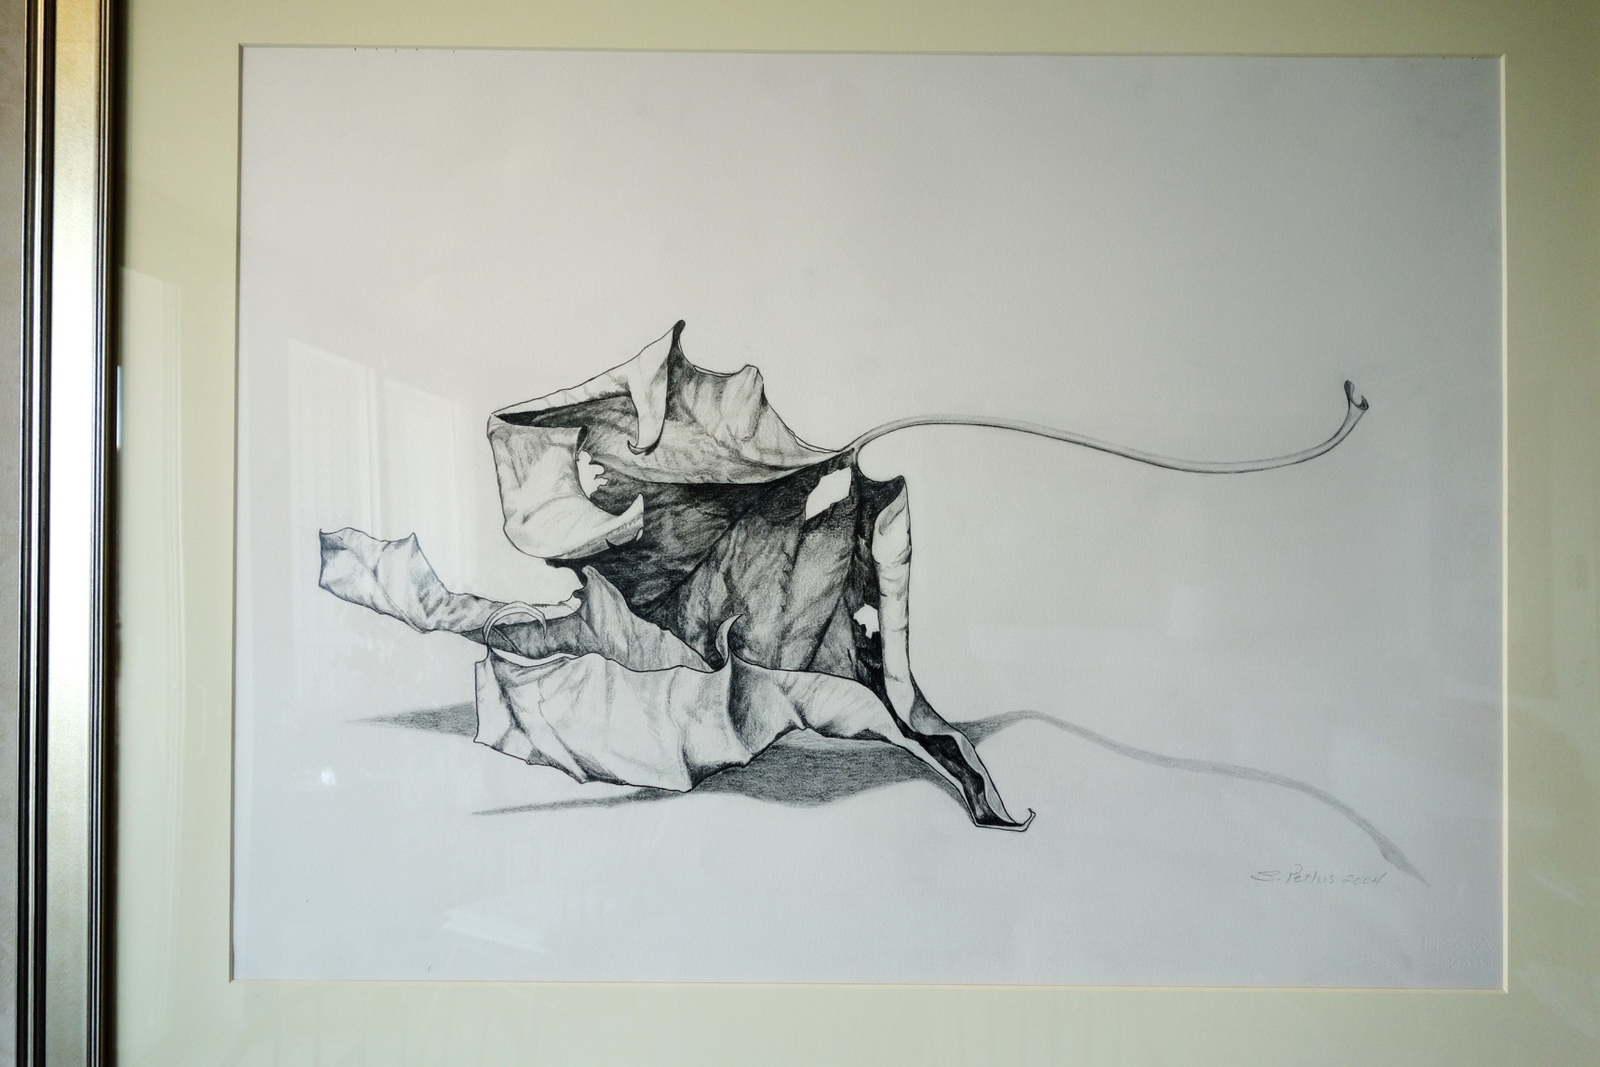
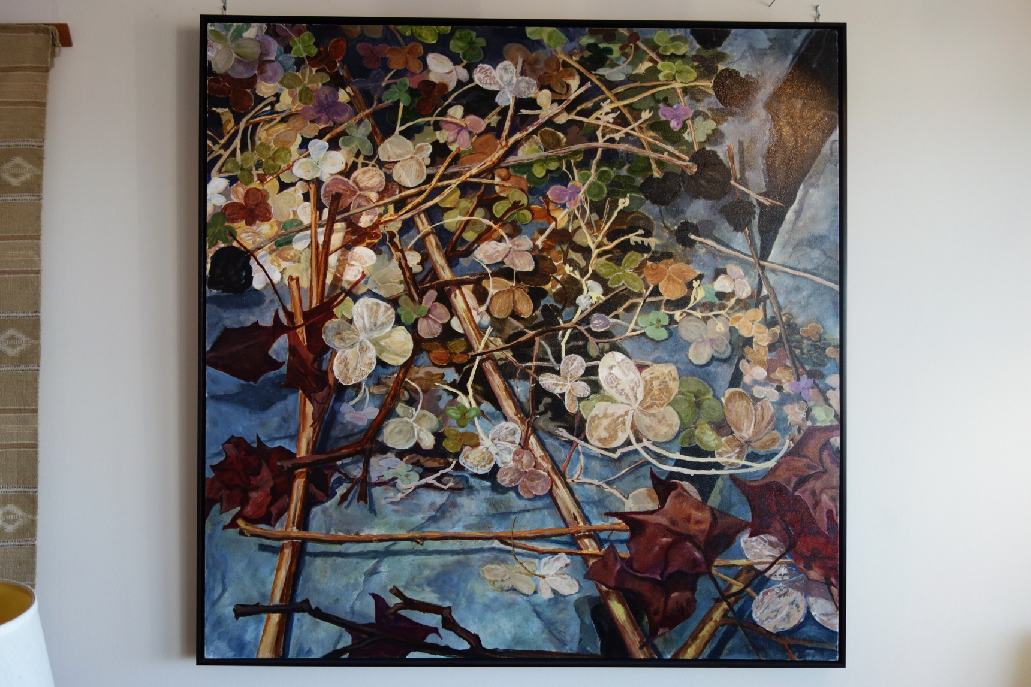

My father’s degree was in business, but he was a versatile musician. He was on the board of the Cleveland Orchestra and the Cleveland Institute of Music, and the president of the Cleveland Philharmonic. His principal instrument was clarinet, but he also could play keyboards – piano, organ and even accordion. The small church in our village had an eight bell chime – and he learned the art of carillon playing just to have fun with it. He ended up playing before and after Sunday services – although he did not like to attend the service. He showed me what he could do on larger carillons in different cites – which was a lot of fun. I joined the church choir at the age of eight. The pay was ten cents a week.

Father liked what passed for HiFi in the 50’s and owned one of the first FM radios. He had a large collection of 78 rpm records, and I loved stacking them on the rather ferocious record changer. The records were in serious danger when they dropped. We always had music when he was around, including at least several chamber music evenings a year when he got a trio, quartet, or quintet together at our house. When I was about eight he showed up with the very first consumer magnetic tape recorder made in this country, a Cleveland-made Clevite Brush Soundmirror. It worked – but with paper tape, permanent magnet erase, and DC bias it had a lot on noise. I soon learned to use it.

David Sings

On acetate tape it did a lot better:

Frank Griesinger plays Brahms

One day when I was about 11 my mother took me to a large bookstore in Cleveland, led me to the children’s section and said I could buy any book. I was intensely uninterested, and walked to the technical section and found a book called “Magnetic Tape Recording” by Marvin Cameras, a renowned expert. It was expensive, but mother bought it. It was full of information, replete with schematics of the best Ampex recorders of the time. Within two years I had built my first tape recorder, out of old motors, ball bearings, rubber belts, vacuum tubes, and wood. It worked, but it had too much flutter for clarinet. I was also struggling to learn to play French horn – as well as singing in the school glee club.

As soon as the CK722 transistor became available I switched to solid state. By the time I was in junior high father had purchased a Wollensack mono recorder. I bought microphones, cables and built my own HiFi preamps and amplifiers. Freshman year at Harvard I bought a Viking half-track stereo recorder and modified it to record at 7 ½ and 15ips, and recorded the freshman Glee Club with a pair of AKG dynamic microphones, but I was unsatisfied with their sound.

Later I found an old Ampex 200 (the big one) at a junk store, and built a complete set of electronics for it. It was later replaced with an Ampex 350 deck from the same source. Sometime before graduate school I built an 8 channel mixer, unique for its time by having a separate VU meter for each channel. This feature turned out to be incredibly useful.

My sophomore year I talked the Physics Lab machine shop manager out of a set of keys, and started machining my own condenser microphones at night. The first was a cardioid, but I soon made a pair of ¾” omnis. The improvement over the AKG dynamics was enormous. I also met Paul Horowitz – an electronics and Physics whiz who became a friend, colleague and roommate. After graduate school I taught Paul’s electronics course at Harvard for three years while I was working on prototypes of the Lexicon 224.

All through Harvard College I was recording every concert I could, working with many well-known conductors and musicians. Many became friends. I continued at Harvard for a doctorate, heavily dependent on electronics I had to build. Graduate school was a joy. I learned an enormous amount of Physics and Electronics – with time to keep recording, singing with the University Choir, and finding time to meet and marry my physicist wife Harriet, who has been an invaluable partner in everything I have done.

As a graduate student I found time to write an AES paper on removing distortion from analog tape recorders, which required adding cross-field bias to my Ampex. Marvin Cameras was impressed. Through Leon Kirchner Harriet and I spent a summer as the recording engineer at the Marlboro Music Festival. It was there that I realized that great microphones and a great recorder are not enough to make a great recording. Working with groups like the Harvard University Choir or the Boston Camerata was easy. I was a musician in both groups, and if there was a balance problem I just discussed it with the conductor. But at Marlboro the musicians did not work that way. They played, you recorded, and you fixed the balance with close mikes and your mixer. (This is where the 8 VUs were really useful.) But the piano was often way louder than the cello. When you close-miked the cello it sounded much brighter and closer to the listener than the piano, which sounded far away. The only solution was to record the cello on a separate track (you needed a 4 track recorder), play it back in the hall through a speaker without the piano, and mix the hall mikes from the playback back into the stereo recording. This gave the piano and the cello equal access to reverberation. The procedure was tedious and subject to interruption from cleaning staff late at night.
The need for artificial hall reverberation was obvious. But there was nothing that worked. I built my own plate reverb – but it sounded like a plate. I experimented with the AKG spring reverb through the local public radio station, but this sounded artificial too. But just then the price of memory began to fall enough that I could contemplate making a digital reverberator. I did not know of the Schroeder experiments with digital reverberation at Bell Labs in 1962. But by then I had made my own microcomputer, so I had the skills. The first digital reverberation device I made used 12 bits, and had hand-wired memories.
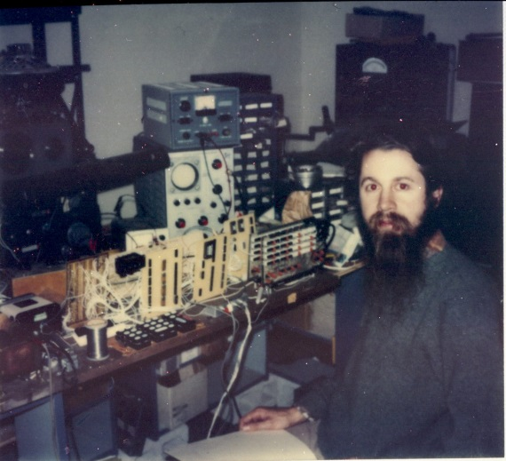

The architecture eventually became the Lexicon 224. This was before there were any digital reverberators were on the market. My first algorithms were promising but not good enough. At a chance meeting Barry Blesser (the designer of the EMT 250 reverberator, which soon hit the market at $30,000, told me about the Schroeder paper. I found it at the MIT library. Harvard did not have it. It was helpful, but I did not like the sound of either the EMT or the Schroeder algorithms. They were all too plate-like. So I made several of my own.

The next prototype was in a pretty blue box, with some commercial Z80 computer cards along with my hand-wired audio CPU, memory, and IO. I loaded the operating system (CPM) from cassettes, and the reverb programs also. The IO was 14 bit implemented with 12 bit A/D and a 2 bit syllabic floating point. The digital system sounded VERY good – better than most, and probably any, commercial digital systems at the time. I used this unit with success on my own recordings and demonstrated it to the president and vice president of Lexicon. They immediately hired me.

We added a remote to adjust parameters, and it became the Lexicon 224. The software was in two assembly languages – Z80 assembler, and an assembly language I devised for the audio CPU. I wrote a primitive higher language compiler for reverberation. You had to know all of them to program the unit. We demonstrated the unit at several trade shows, which generated enormous interest.

The device had several VERY important design features. First – it was a stereo in, stereo out processor. I was enough of a physicist to know that any static impulse response has a sound color. If you mix all your channels to mono and send them through any reverberant system – including a room – the result will have a tone color. In real rooms every instrument has a different reverberation – and many of them move a bit while playing. There is no color when you hear them all together. Using a stereo send and avoiding panning the reverb outputs mitigates the color to some extent. So you need at least two independent inputs and reverb systems and at least two outputs.

The other feature was internal time variance. This also mitigates color, but must be done very carefully. Barry’s EMT also used time variance, but he did it differently. Time variance of one kind or another is an essential feature of Lexicon reverbs.

I continued at Lexicon for another 30 years or so, making new products and algorithms. Along the way I started working with reverberation enhancement in halls – in the process learning a great deal from some wonderful conductors and musicians at a very high level. I continued to work as a recording engineer as much as possible, working with Boston professionals. Working several nights a week gave me a constant opportunity to test different recording techniques, and to perfect my own reverberation algorithms. All the time I was wondering why I was hearing what I was hearing, and what was the physics behind the perception of reverberation. Eventually I was working on these problems full time, and I am still doing so.

About 10 years ago I got very interested in why any (good) recording engineer can instantly hear when a microphone is too far away. Moving the mike just a bit closer can make a dramatic difference to the sound. I began to realize that the same thing happens with human hearing. If you walk away from performers in most halls WITH YOUR EYES CLOSED there is a distinct point where the sound suddenly changes. Forward of that point the sound has a kind of clarity and bite to it. You can localize each instrument precisely and know exactly which instrument played each note. Just a few feet behind that point all this is lost. The sound is loud, sometime pretty, but the localization and clarity is gone. You can hear the notes (most of the time) but you have no clue which instrument played them. The sound is a fuzzy ball in front of you – and it is not compelling to listen to. Open your eyes and you are convinced you are hearing each instrument separately. But you are not.

So clear a demonstration – so un-obvious the physics. In a great burst of total concentration I found a way to explain how the ear and brain accomplished this feat. I wrote a paper about it in 2004 for the International Conference on Acoustics in Japan, and for the Audio Engineering Society conference in 2005. The papers fell flat. Physicists got excited, acousticians and sound engineers thought I was crazy. So I kept working.

About five years ago I had an Eureka moment during a Beethoven string quartet concert. I suddenly realized that the mechanism I had proposed for the distance effect explained almost all the unknown properties of human hearing: the cocktail party effect, the ability to tune instruments to high precision, the reasons we hear pitch in octaves, why fifths and fourths sound so harmonious, why we are so good at hearing signals buried in noise, why mechanical speech to text systems are >10dB worse than human hearing in the presence of noise, why we can separate two simultaneous talkers into two independent neural streams if they are different in pitch by just over ¼ semitone, and why children can’t remember what teachers say in most classrooms. It all depends on the same neurology – neurology that no one seems to know is there, hiding just underneath the basilar membrane.

The consequences for the acoustic design of halls, operas, and classrooms are enormous. You will see a great change in the way these spaces are designed – and soon. The ideas I am promulgating in my papers and talks are beginning to take hold, not as fast as I would like, but faster than I have any right to expect.

I still do some recording, and some performing, mostly as a singer, but sometimes on French horn. A new concert hall just opened that uses my design. You can read about it here:

http://www.classical-scene.com/2014/02/01/new-brooks-hall/

And listen to it from my eardrums in the audience here:
www.davidgriesinger.com/brooks/brooks_concert.mp3

