David Griesinger
221 Mt. Auburn St. # 107
Cambridge, MA 02138
www.davidgriesinger.com
dgriesinger@verizon.net

Bio - David Griesinger - 2015

David Griesinger is fascinated by the relationship between mathematical science and the recording, reproduction, and perception of music. He has given lectures and papers on recording, perception, and room acoustics around the world. His current work is on the mechanisms the ear and brain use to perceive sound, and how these mechanisms are affected by the acoustics in halls, operas, and classrooms of all types. After completing his PhD in physics in 1978 on the Mössbauer effect in Zinc 67, he independently developed one of the first digital reverberation devices, later to become the Lexicon 224. A more than thirty year stint as chief scientist for Lexicon followed, leading to many products, such as the LARES reverberation enhancement system and the Logic7 surround system. He has worked as a classical music recording engineer all his life, an avocation that encourages a certain skill in listening to sound. He has also been active as a singer in various music groups, including the Boston Camerata. He is the recipient of the gold medal of the German Tonmeister Society, a fellow and silver medal recipient of the Audio Engineering Society, and a papers reviewer for the AES, ASA, and Acta Acustica. He has been recently active as a music performance reviewer for www.classical-scene.com, taking special interest in the acoustical quality of venues. He lives in Cambridge Massachusetts, where enjoys his family, concerts, playing French horn, and making HD video recordings of musical performances.
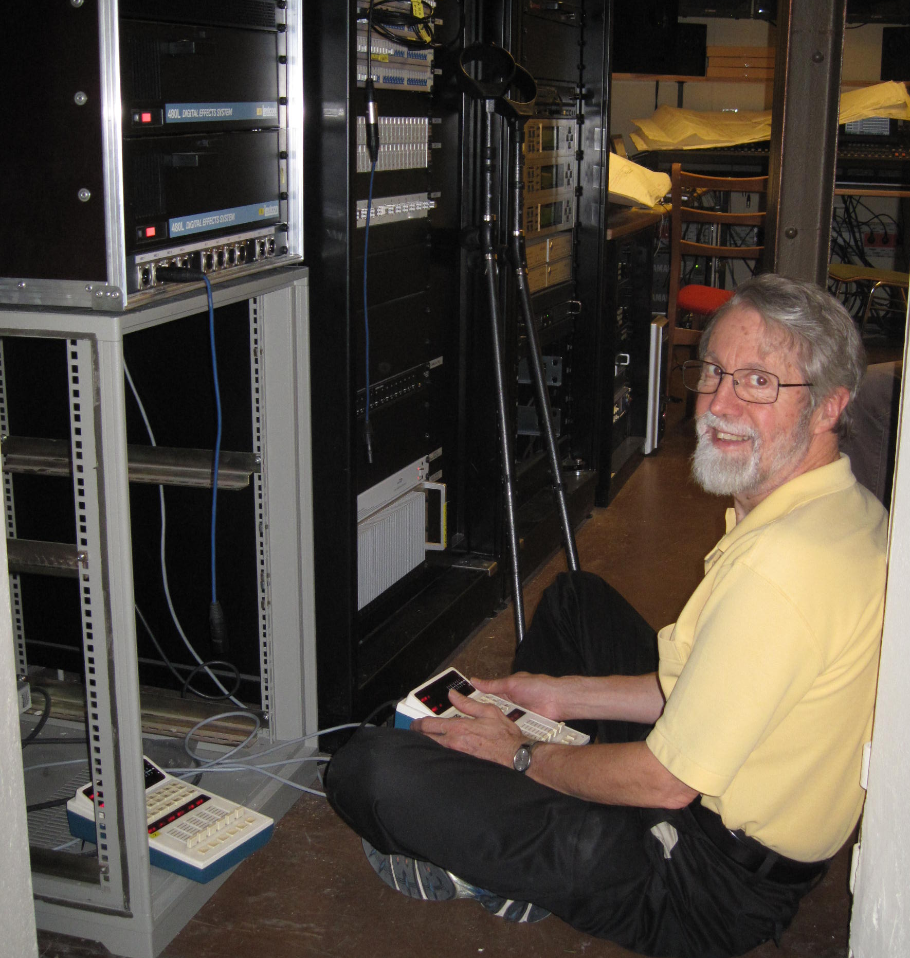

David Griesinger in the Schillertheater Berlin. Photo by Albrecht Krieger, Tonmeister of the Deutsches Staatsoper.

