Presented at the AES conference in Vienna – May 7, 2007 Apologies for the official preprint – the examples do not work.
Perhaps before September I will have time to fill them in – or add audible examples to this paper. Email me if you would
like this to happen sooner.
Perception of Concert Hall Acoustics in seats where the reflected energy is stronger than the direct energy
or…
Why do Concert Halls sound different – and how can we design them to sound better?

David Griesinger
Assuming a reverberation time (RT) of ~ 2 seconds, the decay of sound in most halls is closely exponential – and nearly identical. But halls sound different. Why? We propose to look at how the sound sound rises.

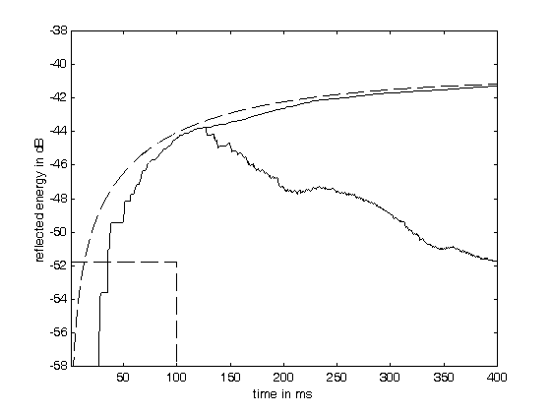
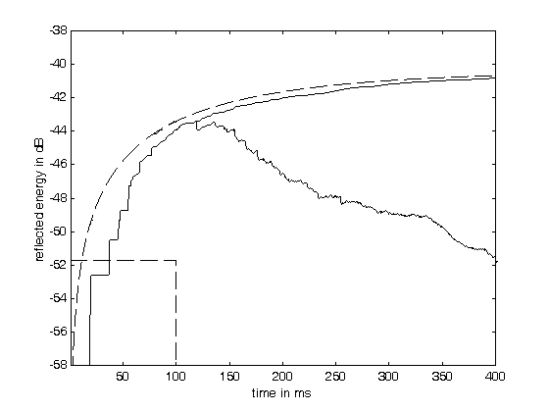

Build up of sound in Amsterdam Build up of sound in Boston

The dashed line shows exponential rise in sound energy from a continuous excitation at the level of the dashed box. The solid line shows the actual rise in the model halls. Note the time gap wherein the direct/reverberant ratio (d/r) is greater than one. For the exponential this time is much shorter than in the model halls.
Modeling with exponential noise:
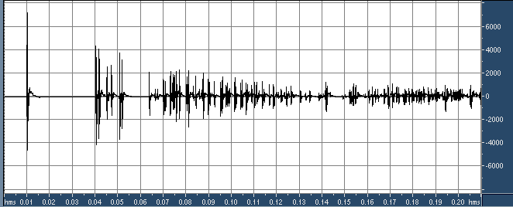
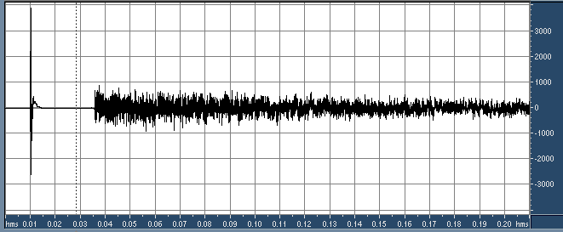
Ipsilateral impulse response from a binaural model of Concertgebouw Amsterdam.

Note the approximately 30ms gap before the onset of reverberation. This gap is determined by the hall geometry.

We can simplify this reverberation by replacing it with exponentially decaying white noise – while varying the time gap before the onset of reverberation.

The cross-correlation of the “reverberation” is adjusted to match the late reverberation in the original models.

The exponential model sounds very similar to the original hall model.

The exponential model sounds very similar to the original hall model.

Source Material:
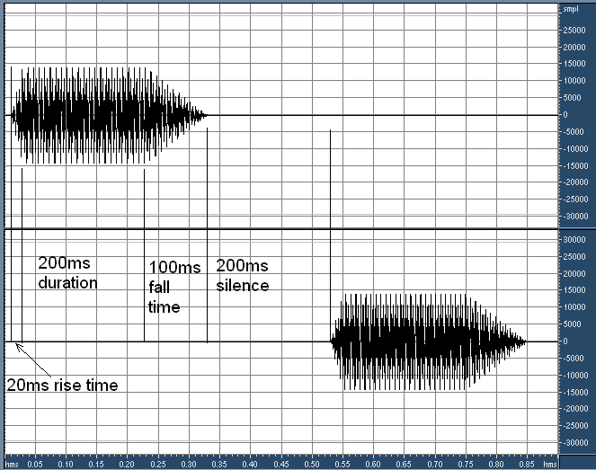
Source Material: A synthesized cello-tone scale and a speech signal (among others) were used as sources. With synthesis the harmonic content, the rise time, the fall time, and the gap between notes could be separately controlled. The stimulus alternates between left and right +- 11 degrees, using KEMAR HRTFs.

The speech signal gave similar results, but the results varied depending on the rise-time and gap length of each syllable.
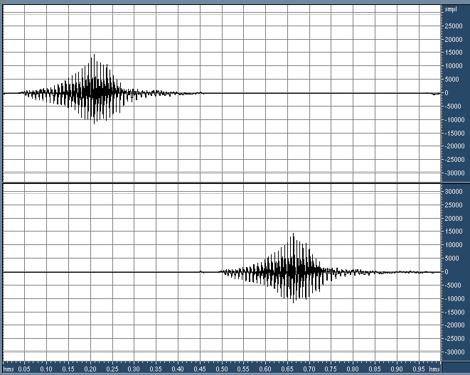

Localization task - Azimuth and Distance with non-directional decays:

Subject varies the d/r ratio (as measured from the C10 of the total impulse response) to find the minimum d/r ratio that produces a perceived source angle of at least +- 6 degrees.
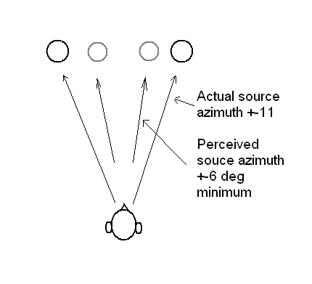

This task is viewed as relatively easy to perceive, and is reliably reproduced by the subject. Distance is perceived as close when the direct sound is detectable.

At the level of direct sound which produces at least +- 6 degrees of azimuth the cello tone is perceived as having a percussive onset – much like a piano. The brain appears to emphasize the stimulus onset (but only if the direct sound is separately perceived, and the pitch of the stimulus is different from the preceding stimulus.
Graph of the minimum d/r which produces at least +-6 degrees of azimuth perception, using a cello-tone stimulus with either 100ms or 200ms gap between each note. RT = 2.0 seconds.

Note as the space between each note becomes larger the direct sound is easier to perceive.

Gaps longer than 200ms produce at best a 1dB improvement.

d/r ratios 2dB higher than these values rapidly produce accurate azimuth. For a 6dB range of d/r the perceived sound is almost identical.

Seats in this range will have quality sound.
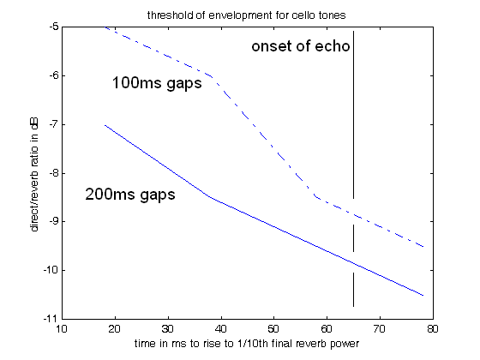

Frequency Dependence:
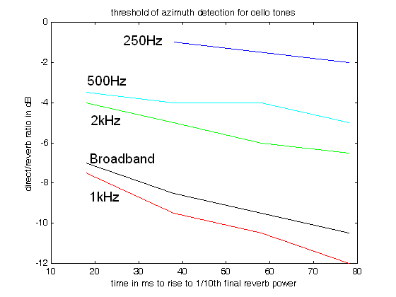
Detection of Azimuth in a Concert Hall is frequency dependent:

The graph shows the threshold of detection for Broadband and several 1 octave bands.

The primary carrier of localization information is the 1kHz band, with localizability rapidly decreasing below and above this frequency.

Other tests show that the sense of distance to the performers is primarily carried by the 2kHz octave band.

And the primary carriers of envelopment lie below 1000Hz.

Hall design implications:

Classical acoustics can be used to accurately predict both the RT and the d/r (C10) at a given seat position. A simple rectangular model will usually predict the time gap for the reverberation to rise to 1/10th the final value at any seat.

Consequently the graph presented above can be used to predict if the direct sound can be separately perceived – and both the clarity and the perceived closeness to the performers will be good.

It is immediately apparent that although the Boston Symphony Hall shape produces good sound over a wide range of seats, if we scale this hall to smaller sizes the sound rapidly becomes both loud and muddy.

Smaller halls need to bring the listeners closer to the performers, using a more square or a ring-shaped design. The ceiling can be raised to increase the reverberation time.

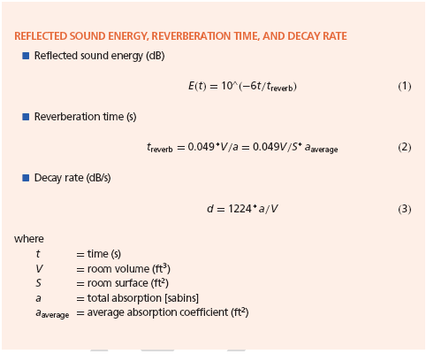
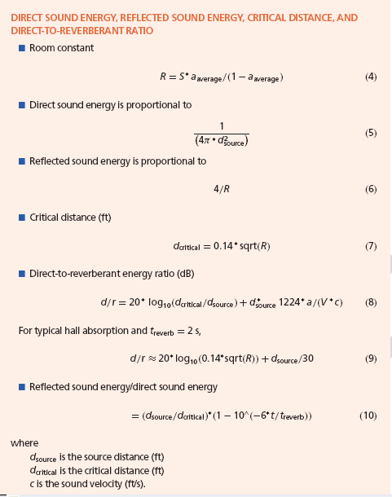

Classical Reverberation formulae from Leo
Beranek’s Acoustics

IACC
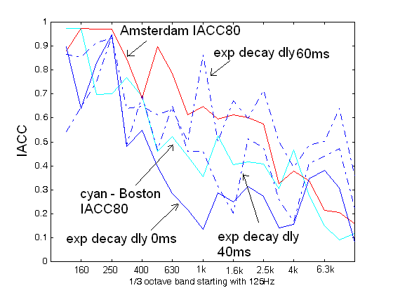
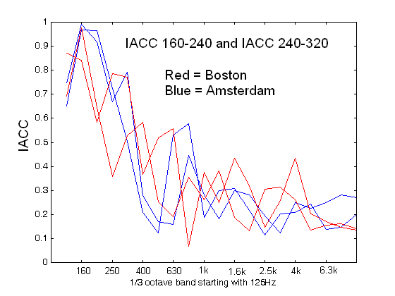
Late IACC in an 80ms window has a frequency dependence depending only on the properties of the size of the head and the diffuseness of the sound field

However EARLY IACC depends MOSTLY on the early time gap. Thus IACC80 and the early gap both reflect the same hall property.

Envelopment:
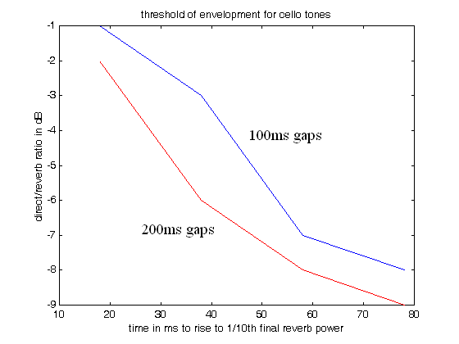

When the LATE IACC is not fully diffuse, the perceived reverberation does not surround the listener, but is perceived in front.

When the direct sound is separately audible the reverberation surrounds the listener.

This effect is also frequency dependent.

Time dependence of Envelopment:
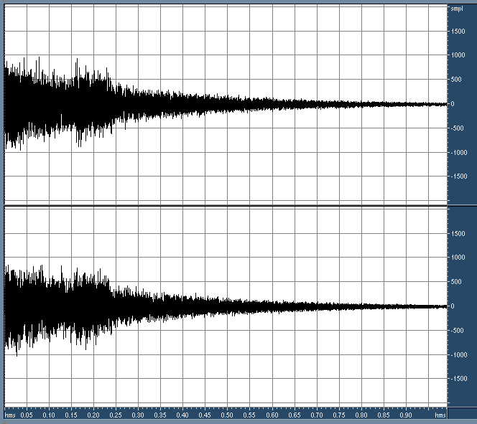

If we boost the exponential decay by 3dB in an 80ms time window centered at 200ms, perceived strength of envelopment increases dramatically.

Envelopment is primarily dependent on the strength of reverberation in the time range of 160 to 340ms!!!

To be continued….

